d

Your Information

Name: | Darren Billy
Email: | darrenbilly01@gmail.com
Mobile Number: | 416-414-2394
Home Address: | 26 Wharnsby Dr
Province: | Ontario
Postal Code: | M1X-1Z2
Current Club: | Pickering FC

Personal Goal Setting

Goal setting is a key component to success. Countless books and articles have been written over the years about this topic, and there are many methods that can be used to achieve your goals. Read the following from James Clear, the best-selling author of ‘Atomic Habits’ for more insight: Goal Setting: A Scientific Guide to Setting and Achieving Goals

Use the table below to outline your short, medium and long-term goals.

0 to 1-year Goals
In my first year of Coaching I hope to work as a League 1 U20 Coach as a past player I feel this would be a major accomplishment for myself. I want to develop smart players that understand the game and will be high level players. This is really important in my year 1, after completing my Concacaf B License. Some of the things that will help me to become a League1 U-20 Coach will be to continue developing players at the recreational and competitive ages. Some of the skills sets that I still need to master is my ability to develop players. The development of players and showing proof of continued player growth will provide me the opportunity to coach at a higher level.
1 to 3-year Goals
In my year 1-3 I’d like to be working as an assistant Coach in League 1 Ontario or possibly as a head Coach. I think the time working as an Assistant Coach will help me gather relevant Coaching knowledge that will help me grow as a Coach in my respected field. I think the fact that I’m currently working as an Assistant Coach and having success will lead me to becoming a Head Coach of an OPDL team. Once a head Coach of an ODPL team, the next stream would have me assisting as an Assistant Coach for a League 1 Team. After Success as a League 1 Assistant Coach, I feel that this will improve my chances of me being hired as a League 1 Coach. If I follow these steps I believe it is inevitable to become a League 1 Ontario Coach and move up from there.
3 to 5-year Goals
In my 3-5 year goal, I’m hoping to be a head Coach of a League 1 Ontario club and possibly be looking to join a CPL club as an Assistant Coach or as a Head Coach. I would like to be able to Coach at a very high level preferably professional or at a Collegiate level. I would like to possibly be sitting on the bench as an assistant with an MLS or USL club in the states if possible but I know it would be difficult being a Canadian Coach and not holding my Canadian License. Some ways that I believe I can develop my Skillset and experience needed to reach my 5-10 year goal. Would be by gaining valuable experience, maybe shadowing current high level coaches or asking to assist for a season or two as a volunteer coach. There is also the option to pursue my european coaching license which will in turn better my chances of being hired as a first team coach, because it will broaden my market with opportunities to coach in Europe as well. As someone who hasn’t seen anyone progress from a grass roots coach to a First team coach. I’m not sure how realistic these goals are but, I can use this as a template and reassess my goals after 2-3 years and see how I’m progressing and try to re-align my goals.

Personal SWOT Analysis

A Personal SWOT Analysis is a framework for you to assess your strengths and weaknesses and the opportunities and threats that you face, both personally and professionally.

The goal of your Personal SWOT Analysis is for you to explore your strengths and weaknesses in detail, to outline the opportunities and threats that exist in your current and future environments, and to use this information to create a plan for successfully achieving your goals.

Please complete the table below.

Strengths
Some of my strengths as a Coach is my ability to connect with the players and an extensive understanding of the game. As I had played for many years, I’ve also developed the tenacity that knowing to accomplish certain goals you must be able to withstand pressure and be able to focus for extended periods of time.
Weaknesses
My weakness would have to be my time management, having to juggle school and my coaching schedule will be very tough at times especially commuting back and forth for classes and not having adequate locations to study and complete my work. This will be a challenge, and would fall under a category of my weaknesses.
Opportunities
Some of the opportunities would be the ability to work with other Coaches who are aspiring to Coach at a high level like myself. This is something that is exciting and working with Instructors from Canada Soccer who have a wide range of knowledge and an eye for the game and developing players that I may not see at times. This can be very helpful and can help push me in my journey.
Threats
Some of the threats is the possibility of failing, i understand that if certain sections of the Coaching License are not handed-in in time then I could possibly fail and not become a certified B license Coach would be a threat to my development and my plans to progress as a high level coach in the sport I love. Therefore I will stay on top of my tasks and always be willing to chat and acknowledge my assessors and stay up to date on my deadlines.

Reflection Journal

Please fill in the tables below. Use the spaces provided to summarize each module and outline your thoughts and key learnings.

Module 1 - WELCOME & OBSERVATION OF COMPETENCY
Date: | Sunday August 10, 2025
Facilitator(s): | Zachin Automotive Center
Module Summary: | Introduction & Observation of Competency
IN THE HANDBOOK REVIEW THE OBSERVATION OF COMPETENCY GUIDE FOR THE 2 COMPETENCIES AND SKILLS FOR THE PORTFOLIO & CAPPING PROJECT.
IDENTIFY WHAT BEHAVIOURS YOU PERSONALLY WILL NEED TO PRIORITIZE TO HAVE SUCCESS?
In order to be successful in the competency process, I will prioritize behaviours connected to Curiosity and Openness, outlined in the Coach Education Principles.

Curiosity - Clarity and Adaptability

On the field, I will focus on clarity by clearly explaining coaching points, using simple language and consistently checking for players' understanding. I will ensure that activities and cues connect directly to the game so players understand the purpose of what we are doing. I will also demonstrate adaptability by adjusting activities based on player needs and involving players in problem-solving rather than only providing solutions.

Off the field, I will use clarity in my planning by setting clear learning objectives and ensuring my session plans reflect the realities of my players and environment. I will reflect on the session to identify what worked, what didn't and how I can adapt future sessions to better support. Player learning .

Openness - Empathy & Reflection

On the field, I will prioritize openness by focusing on progress over perfection. THis includes showing empathy, listening to players’ and responding calmly to frustration or mistakes. I will create an environment where players feel comfortable asking questions and taking ownership of their development.

Off the field, I will actively seek and take player feedback seriously , using reflection to guide improvements in my planning and coaching approach. I will remain open to learning from others and adjusting my coaching philosophy as I continue to develop.

By prioritising these behaviours I will be better positioned to build a clear game model and style of play that fits my players and supports their long-term growth.

Module 2 - DEVELOPING THE CREATIVE & ADAPTIVE PLAYER
Date: | Monday August 11, 2025
Facilitator(s): | Mark, Dave, Miranda
Module Summary: | Environment Design
OUTLINE YOUR TRAINING DESIGN PRINCIPLES INCLUDING THE RATIONALE FOR THEIR SELECTION (EXAMPLE: REVIEW THE SCORE ACRONYM)
Soccer Problem:
I'm trying to encourage my players to mark within the midfield and support the defenders when the opposing team tries to overload in the central channels.
Challenge:
I have to do this in a way that is relevant to the game and how the game is played. I want my players to learn how to adjust and I believe it can be competitive and is appropriate for the ability of the players as this is something we are challenged with weekly in games.
Opposition:
I want to start with creating repetitions so that the players can understand the problem and then give them new ways to figure out how to avoid the situation or how they can handle it smarter.
Realism:
The plan is to make it as real as possible but it will be tough because the attackers will also try to find new ways to attack once the defenders start to get the hang of how they are marking them in the middle.
Enjoyment:
It can be enjoyable and competitive because I want to make it so that both players are able to score goals and compete which is the important part in running these sessions so that the players can learn something new and improve their overall footballing ability.

TRANSFER THE PRACTICE ACTIVITY MAKING ANY ADJUSTMENTS WHILST ALIGNING TO YOUR TRAINING DESIGN PRINCIPLES

Google Slides: Copy your Slides from the Session Plan Template > Click in the box > Paste > Link to Presentation
Microsoft Powerpoint: Take a screenshot of the Slide > Click in the space below > Insert > Image > Upload from Computer
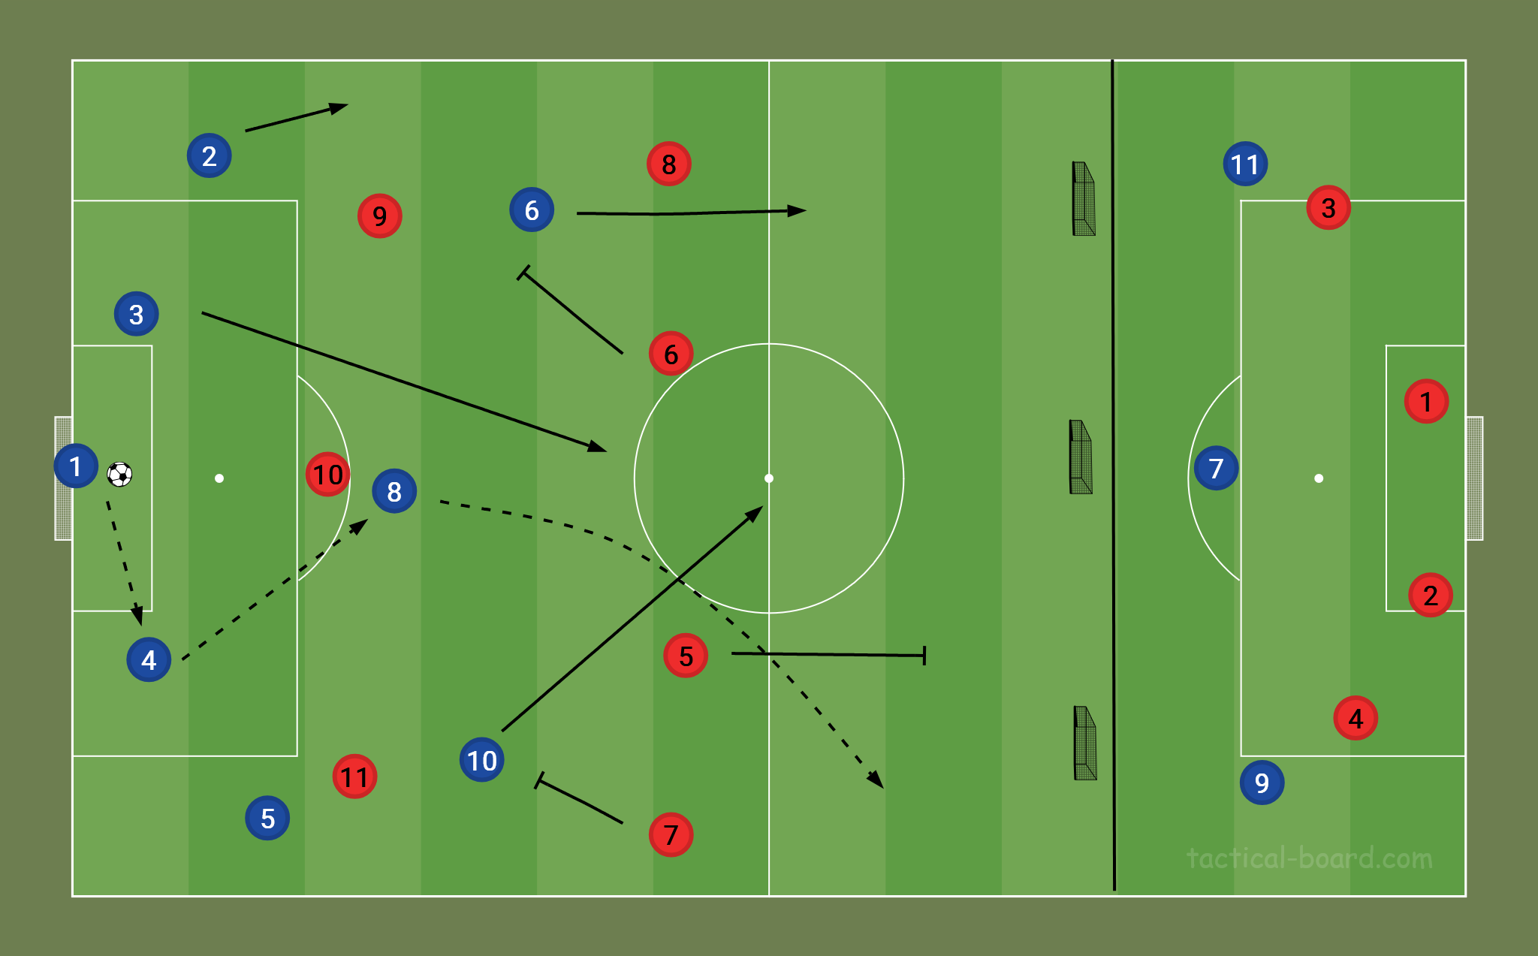
ADDITIONAL REFLECTION & NOTES
Thinking of how I can make it more interactive with both sides. I understand that after a while it might become repetitive so finding ways to make it more fun and game realistic. I want to challenge the players to make decisions so maybe I can throw another player in the mix and see how we can improve the game and have the players make more game-like decisions. With the progression it might be tough because we are playing from both sides and there is no numerical advantage. But it would be good to have both sides attempting to build from the back and making this more game-like rather than another progression that is like moving more into the game.

Module 3 - PRACTICE METHODOLOGIES & ADVANCED ACTIVITIES
Date: | Tuesday August 12, 2025
Facilitator(s): | Dave, Miranda, Mike
Module Summary: | Methodologies & Advance Activities
MY OPINION

WHAT CONSIDERATIONS DO YOU NEED TO CONSIDER FOR USING DIFFERENT PRACTICE SESSION METHODOLOGIES?
Some of the considerations that would be made to determine the practice sessions methodologies would be the Coaching Philosophy, in the sense of how you want to play and the style of football you want to play. This will help you better understand how to plan your session.
Motivation of players, if players are highly motivated then the session will be a much better session in the sense of the level of output from the players. We can also use the Position specifics of the sessions. Who is this session focused on for what players and what positions and what part of the game. Would it be applied when we are in possession or when we are out of possession. Maturity of the players is also very important. If the players are not very skillful then asking certain things of them is very hard to come by . If they are not skillful enough to play certain times of football in a sense of footballing ability, are they able to keep the ball, do they understand when to keep the ball and when to attack space and move the ball forward.
In regards to WHW and PPM. I think the WHW would be ideal in a situation like this based on the skill level of the players. Where I would have to monitor the skill and then adjust the session accordingly to go over the exact movement or moment that I’m looking for and how it can be created. If I were to do PGm I think it would be tough because they might not be able to perform the skill so having them practise it before teaching it to them would be tough, therefore going over it during the game and reviewing it i think would be the best method in this situation.
UPLOAD THE FUNCTIONAL SESSION

Google Slides: Copy your Slides from the Session Plan Template > Click in the box > Paste > Link to Presentation
Microsoft Powerpoint: Take a screenshot of the Slide > Click in the space below > Insert > Image > Upload from Computer
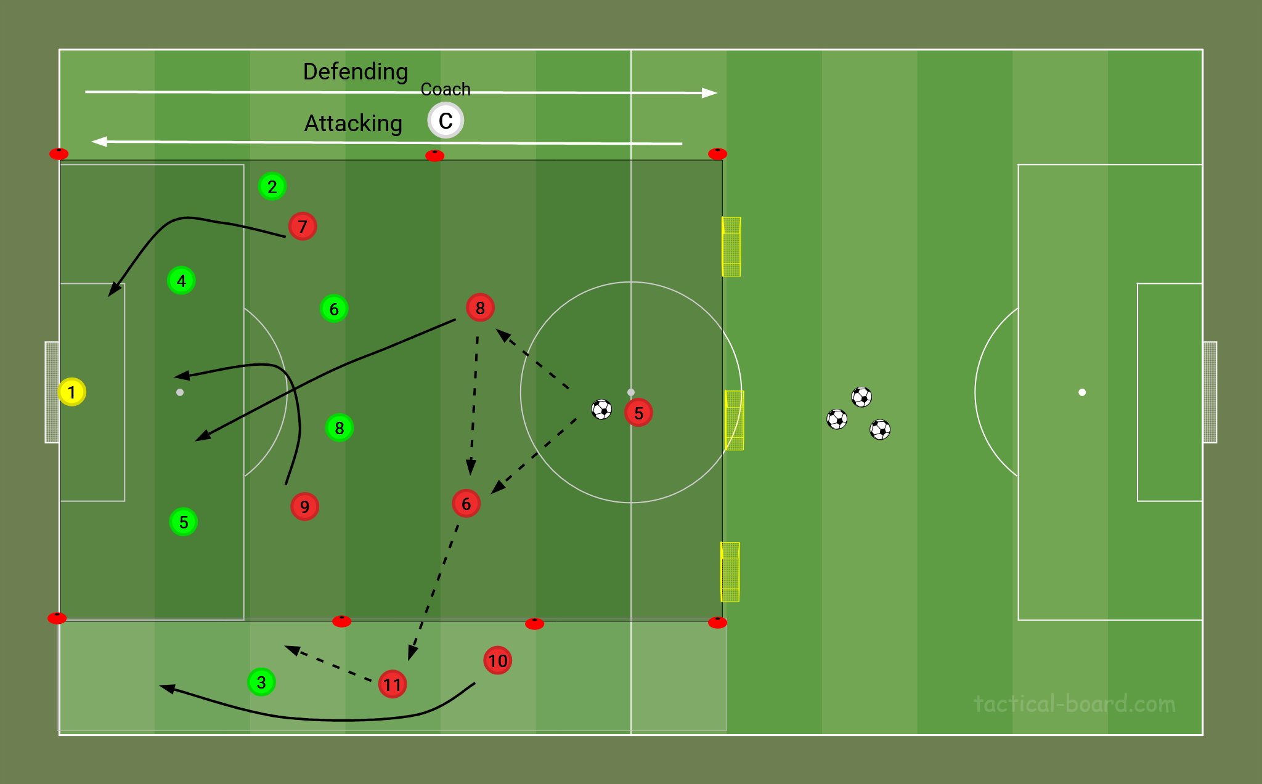
ADDITIONAL REFLECTIONS & NOTES
When attacking from crosses into the box it is important to attack the goal and try to sneak in behind the defender.

Module 4 - DESIGNING YOUR GAME MODEL PART 1
Date: | September 9, 2025
Facilitator(s): | Dave, Mike, Miranda, Nino
Module Summary: | Developing a Game Model
FINALIZE YOUR STYLE OF PLAY WITH ONE OR TWO PARAGRAPHS
We want to play attacking football where we look to move the ball up the field from the wide channels, and have players attacking channels 3 and 4 in zone 4. This is why we want to attack with a 1-4-4-2 with only two attacking players. We can have our wingbacks get into central positions when we are looking to get crosses into the box.

When we defend we want to be in more of a 1-4-2-3-1 so that we can be more defensive and be compact and force the opponent to the wide channels. We want to enforce a low block where we only look to defend zones 1-2 into 3 but avoid a high press/ This would provide us the legs to counter quickly and disperse back into our attacking formation.
IDENTIFY HOW YOU WILL PRESENT THE MOMENTS OF THE GAME

Recommendation: Use graphics and diagrams
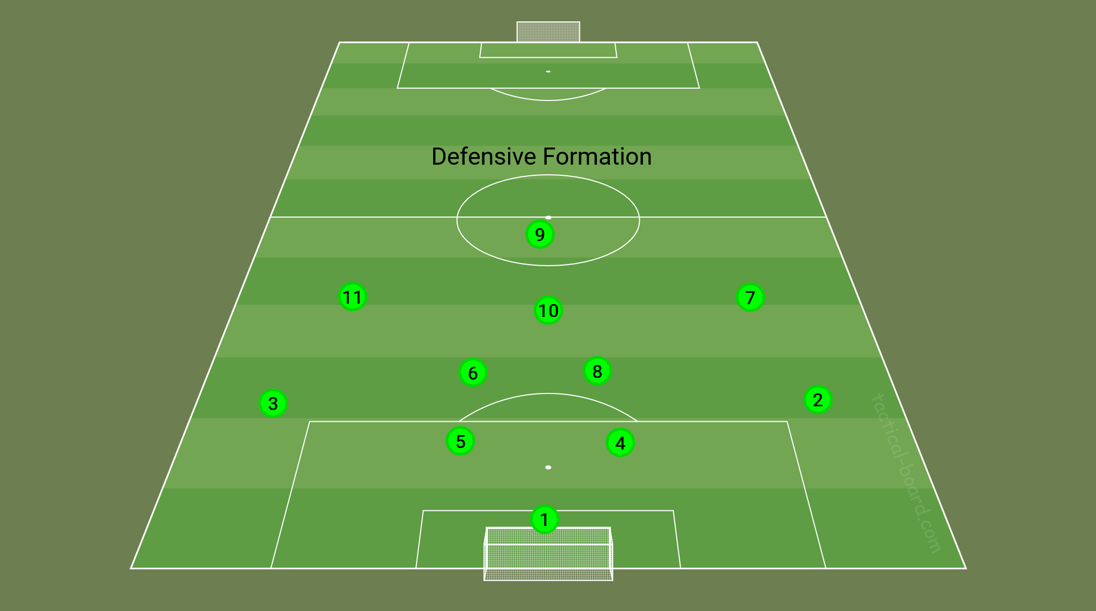
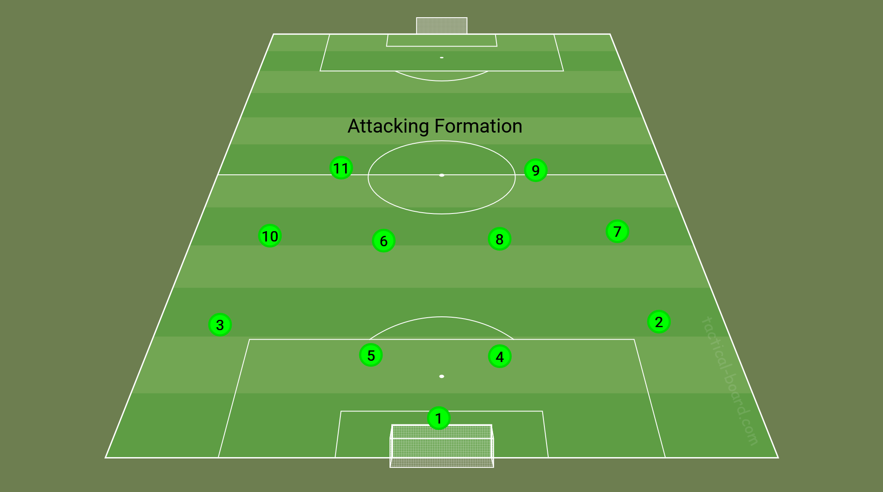
ESTABLISH YOUR PITCH GEOGRAPHY

Recommendation: Use graphics and diagrams
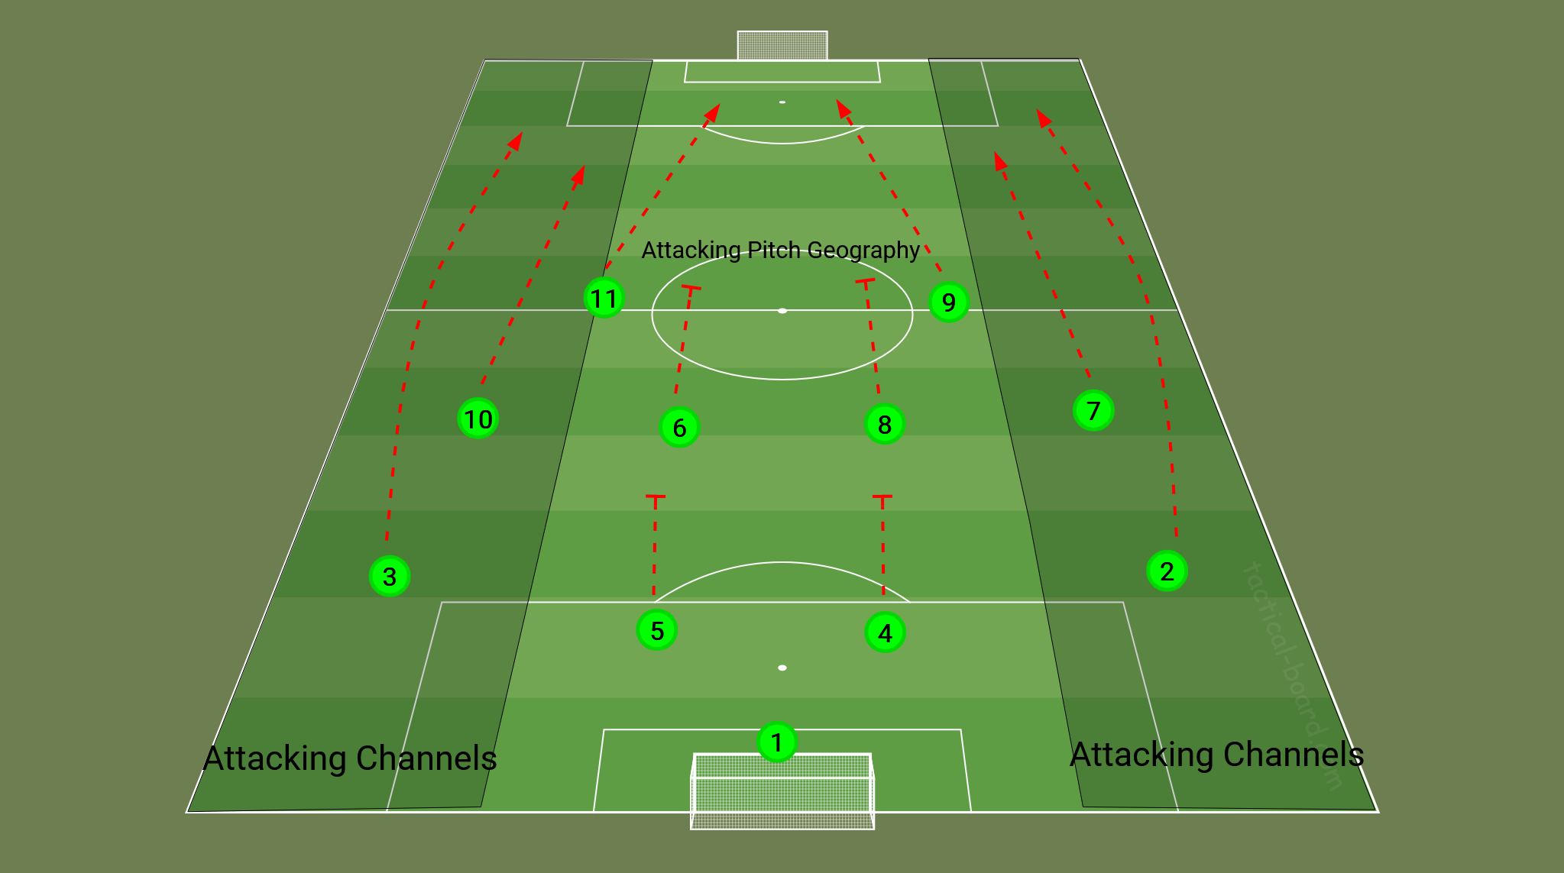
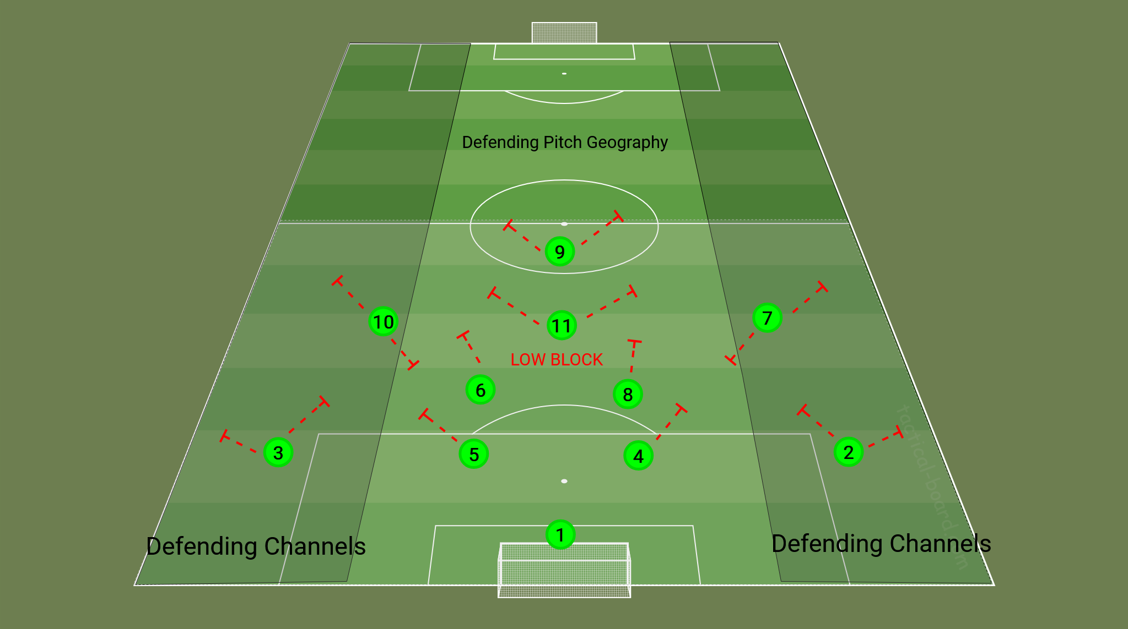
LIST POSSIBLE SYSTEMS ALIGNED TO YOUR STYLE OF PLAY, MOMENTS OF THE GAME & PITCH GEOGRAPHY
Our strategy would be to stay compact when defending and pick our moments to step out wide and defend wide areas. I would like our defenders, especially my CDM to stay central and go out to help the 2 or 3 defending in 1v1 situations. This would provide the defending depth we need to be successful. Also as one CDM shifts to defend the wide channel the other being the 6 or the 8 should also step into the central zone 3 and help defend the gap that has been left open.
LIST POSSIBLE STRATEGIES ALIGNED TO YOUR STYLE OF PLAY, MOMENTS OF THE GAME & PITCH GEOGRAPHY
When we are into zone 3 playing into zone 4 our 11 should start to get up the field and inline with the 9 helping him attack the central channel. Our 7 & 10 should look to get wide with the 2 & 3 looking to support and make overlapping runs and support the attacking play so that we can provide an overload on the wings. This will help us get plays into the box and support our attacking transition.
ADDITIONAL REFLECTIONS & NOTES
Always looking to play forward but when we cannot play forward look to reset the ball and maintain possession. We should not be looking to constantly play long. We should be using the wide channel to bring the ball forward and using our central players to help us transition the ball wide when need be. We can also keep working on distribution of the ball to wide areas helping us get forward.
UPLOAD THE PHASE OF PLAY SESSION

Google Slides: Copy your Slides from the Session Plan Template > Click in the box > Paste > Link to Presentation
Microsoft Powerpoint: Take a screenshot of the Slide > Click in the space below > Insert > Image > Upload from Computer
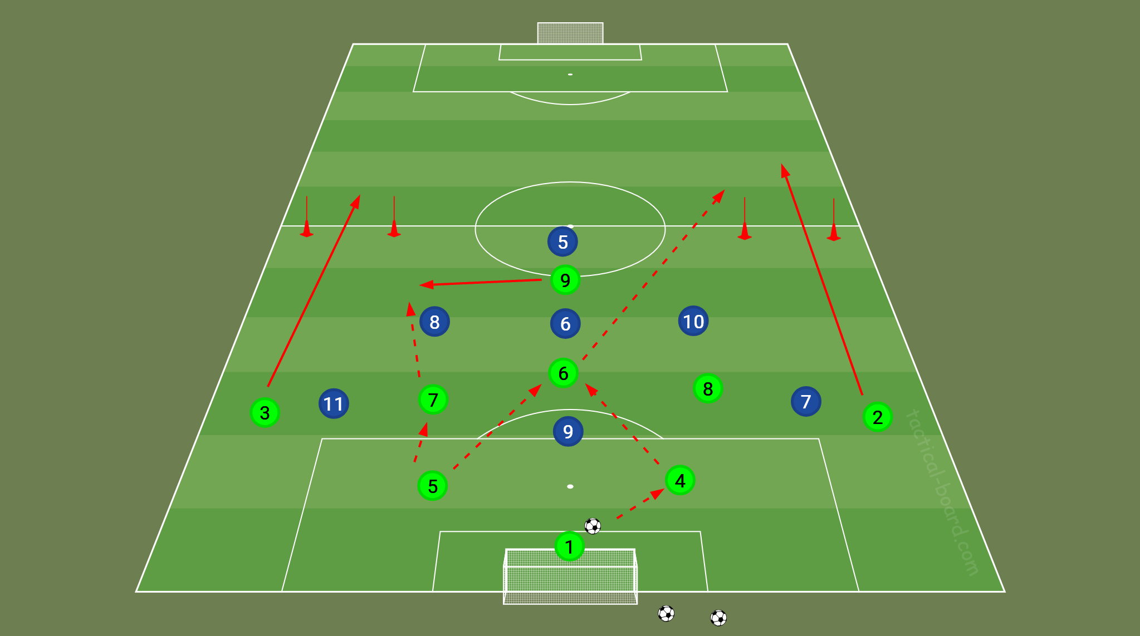
ADDITIONAL REFLECTIONS & NOTES
In this activity the focus is the build up from central channel to wide channel the emphasis is that the players are to use the central channels to help them transition from side of the pitch to side of the pitch trying to avoid build directly down the middle of the pitch. In doing so we hope to create and off balance so that we can easily find the layers making overlapping runs in the wide channels.

Module 5 - TRANSFORMATIONAL COACHING: A COMPLEX SOCIAL PROCESS
Date: | Sunday September 14, 2025
Facilitator(s): | Dave, Mike, Miranda, Nino
Module Summary: | Social Complex Process
TOPIC

ONE THING I FOUND VERY INTERESTING ABOUT THIS MODULE WAS...

A QUOTE FROM THE MODULE THAT STOOD OUT…
One quote that I found very interesting was this quote “Adults often find learning challenging because they’re not just adding knowledge; they’re rearranging their entire mental furniture. It;s like trying to renovate a house while living in it- disruptive, disorienting, and demanding.” This really resonated with me because this is a lot like coaching a team, you have different players with different skill sets and trying to arrange them in a fashion so that all parts are able to work together to conquer a common goal. Every player wants to do their own thing and certain players want to play their own style of football and my job is to manage the house with all the moving parts and different items in the house to make the house look like a beautiful and great place to both live and stay . This is the job as a coach and is not always an easy task and is not always a pretty job but is something that needs to get done.
CONNECTION TO MY ENVIRONMENT

REVIEW YOUR BASELINE VIDEO AND REFLECT ON THE MODULE AND ANSWER WHAT YOU WILL START-STOP-CONTINUE TO DO.
After reviewing my baseline video I will start being more intentional with how and when I intervene, particularly during live play. Using the Engage and Explain stages, I will set clearer expectations at the start of sessions so players understand the purpose of the activity and what success looks like. During sessions, I will use Educate moments more deliberately, engaging players feel involved in the learning process and support intellectual stimulation rather than dependence on coach instruction. I will also START ensuring that pliers have opportunities to rehearse solutions after an intervention, aligning with the Ensure phase, so learning is reinforced through action rather than words alone.
Also after reviewing my baseline video, I will stop making immediate comments or interventions that may unintentionally shift focus away from the players’ experience even when the intention is positive instructional. Specifically, I will stop acting as a constant ‘devil advocate’ during live play, I will also stop or cut down how often I make comments that could be interpreted as judgment rather than guidance. By improving my Exit and Enter decision, I will avoid stepping in unless I can clearly add value, reduce anxiety and protect the flow of the session. This will help prevent players from feeling overly observed, evaluated or discouraged.
Finally after reviewing my baseline video I will continue to prioritize the player's first perspective when coaching, recognizing that players experience feedback differently based on confidence, personality and context. I will continue to reflect on the emotional and psychological impact of my coaching behaviours. I will use empathy and listening to better understand how players feel. I will also create an environment where mistakes are viewed as part of the learning process, Through Ensuring and post session reflection, I will continue to check whether my coaching behaviours are supporting confidence, engagement and long term development rather than short term compliance.

ADDITIONAL REFLECTIONS & NOTES
This is something that is very important especially as a coach who has played the game for many years, I have an understanding of what works from a players perspective and what hurts from a players perspective coming in front of the coach. What you say in your head might seem harmless but in the eye of the player they see things differently, not every players receive there message the same way some may see it in a negative light and some may see it in a positive light some may take it as a way to do better and some may take it as a negative moment and not be able to perform at a high level after the comments that have been made.

Module 6 - UNDERSTANDING TACTICAL RESPONSIBILITIES
Date: | Wednesday September 24, 2025
Facilitator(s): | Dave, Mike, Miranada
Module Summary: | Identifying different Player Position Responsibilities
TOPIC

ONE THING I FOUND VERY INTERESTING ABOUT THIS MODULE WAS...

A QUOTE FROM THE MODULE THAT STOOD OUT…
I found that identifying players' roles is important especially at youth level. Players in the heat of the game tend to forget their roles or in other terms forget their roles and leave their team vulnerable to attack. Having different players understanding their roles, specifically player positions roles. It is very important because when a player is asked to play a different position on the field their roles change drastically. This makes it very important and relatable to player development.
MY OPINION

IN MY OPINION...

FROM MY OWN EXPERIENCE...

IN MY OWN LIFE...
In my opinion as a player not all coaches take the time to go over what a players role is. Especially before a game, having a player know his role and go over it consistently over the course of the week heading into the game. The player is more equipped to be successful, this makes it so that players are able to be prepared for the match. From my personal experience not many coaches go over this and in my own life this is something I intend to incorporate into my personal sessions and into my teams as we move forward.
CONNECTION TO MY ENVIRONMENT

What can you start doing in your environment considering positional responsibilities & unit relationships in your training environments
In my own environment I will start to go over players' positions and their roles on the field. I will also go over the secondary position that they tend to have to cover for on the field so `in the casse that their role changes on the field they are able to adapt. A lot of times in games players have to switch positions for segments of the game and when that happens players must understand what their new role is and be able to play it for the segment of the game that is needed.

Baseline Practical Coaching Video Reflection

Once you have filmed your practical video, complete the following self-reflections under each competency consideration by providing evidence according to the criteria. Please use timestamps where appropriate.
Competencies: Clarity, Adaptability and Problem-Solving (See the handbook for a more detailed examples)
- The coach clearly communicates objectives, utilizes tools effectively, and uses language consistent with their established game model.
- The coach manages the environment effectively, modifies sessions based on player needs, adjusts difficulty to match objectives, and utilizes varied restarts to challenge players.
- The coach communicates solutions effectively, understands the impact of decisions on outcomes, and recreates game moments to enhance player problem-solving.

In the space below, insert your self-reflections for these competencies
:30 I go over with the game board so players are clear and have an understanding of what the tactics and how it looks on the board. I give each player an objective and an understanding of what they are supposed to do given their positions.
2:37 I stop to give instructions to the players and provide the players details in regards to positioning and why they should be there and instruct one of the players to get to that position.

Competencies: Organization, Time Management and Self-Regulation (See the handbook for a more detailed examples)
- The coach understands session methodologies, designs cohesive sessions, and meticulously plans all essential components, including identifying key players for unit cohesion.
- The coach communicates expectations clearly, encourages independent exploration before intervention, and provides appropriate playing time considering player needs and session objectives.
- The coach remains composed under pressure, exemplifies their values, and aligns with the club's philosophy.

In the space below, insert your self-reflections for these competencies
4:58 I go over position specific independent exploration on who should be stepping out to mark who and in what area of the pitch. I play out the action so the player gets the opportunity to recreate the action and have a better understanding of the methodology that I am trying to teach.

I always stay composed under pressure even when the activity is not going the way i want it to or when a player is not doing exactly what I want, i give him the time to make he mistake and then I attempt to go back and correct him and lead him into a discovery of what else he could have done or how he could have dealt with the situation better.

Competencies: Empathy, Compassion and Critical Reflection (See the handbook for a more detailed examples)
- The coach creates a safe learning environment, actively seeks feedback, and allows players opportunities for practice after interventions.
- The coach values player input, fosters an inclusive environment, and uses a feedforward approach in feedback.
- The coach understands strategic positioning for effective coaching, observes key moments during sessions, and facilitates debriefing sessions for player reflection and self-evaluation.

In the space below, insert your self-reflections for these competencies
13:38 I take the time to go into details of some of the behind the scenes from a play that happened over the weekend with our call up goal keeper. I know during the game I don't have the opportunity to go over these things so during our change over. I use this as a time to teach him and let him know things that can help him improve his game and let him become a better player.
15:02 I ask open ended questions to provide the players opportunity to learn and to ask questions about what we are trying to accomplish in this training session. It is something of a guided discovery where the player gets the opportunity to learn as we go along and we get the chance to have a discussion with his team mates.

7:32 again stopped the game to ask about the shape and our organization.

Competencies: Authenticity, Engagement and Risk Management (See the handbook for a more detailed examples)
- The coach displays confidence in their vision, prioritizes personal connections with players, and shares personal anecdotes to build rapport.
- The coach engages players in understanding objectives, employs diverse coaching approaches, and creates a fun, game-like environment.
- The coach prioritizes safety by assessing requirements before the session, monitoring the environment throughout, and regularly checking on players' well-being.

In the space below, insert your self-reflections for these competencies
&:32 Again I ask the players about our shape and receive feedback and then we continue to make a discovery as the players are getting the chance to learn as we go along with the training sessions.

I always try to make sure that there are no objects on the field and that the players are equipped with shin guards and that they have no jewellery or no earring in their ear.Things that could be perfectly hazardous if not checked prior to the start of a training session.

I always try to make the activity fun by engaging with the players and making them fully comfortable and making sure all players are respectful in the way they interact with their teammates. I know that a positive environment is always the best way for a player to learn and anything else can be destructive to their long term growth.

Competencies: Communication, Relationship Building and Conflict Resolution (See the handbook for a more detailed examples)
- The coach adapts communication style to suit players, motivates effectively through words and tone, and speaks confidently using clear language.
- The coach fosters a collaborative environment for exploring solutions and encourages active sharing and integration of knowledge during briefings.
- The coach addresses player disagreements and reinforces team objectives, while also demonstrating a thorough understanding of game rules.

In the space below, insert your self-reflections for these competencies
I use my words and tone carefully in games. I won't deliver the same message I deliver in the training session in regards to tone. Training is the best time to learn if we are d1 before a game and we need to get something engraved in the players mind then my tone might change but d5 when we have just played a game or we don't have a game for a long time I give the players a lot of options and try to make the training session more fun and have the player express themselves and play with freedom.

When players disagree I try to nip it in the butt early so that it doesn’t turn into something larger than it needs to be. Players will always have disagreements if you have them playing in a competitive environment. This is part of football competitiveness. Players need to compete at a high level both in training sessions and in game if you want to get the best out of your players. Other players might take it upon themselves to push their teammates to get the best out of the teammates in the session and try to push them . We have to be careful in the delivery of this because not all players take the message in a positive note that we spoke about before. Therefore sometimes I have personal conversations with the players and let them know what my expectations are of the players and who I feel they need to do what they should be doing. All my players do well in their position and when they don't I usually go over what they could have done better. Players have ups and downs so it is important as a coach to understand not every player is going to perform at their best at all times as this is just impossible. But you can push them to work at their hardest as this is something that is possible.

Practice Sessions
Please upload two (2) full workouts you conduct with your team. Ensure that the following details are included:

- Session Objective & Learning Intentions
- Age and level of the players
- Moment of the Game
- System-Strategy identified for both teams
- Tactics-Skill Sets for the team you are coaching
- Resources
- Overview of each activity inc. time
- Progressions / Regressions
- Role of the assistant coach
- Coaching details (WHAT-WHO-WHERE-WHEN-WHY-HOW)
- Diagram that presents a specific moment and aligns to the coaching points

Practice Session Example
In the space below, insert your session plan details by:
Google Slides: Copy your Slides from the Session Plan Template > Click in the box > Paste > Link to Presentation
Microsoft Powerpoint: Take a screenshot of the Slide > Click in the space below > Insert > Image > Upload from Computer
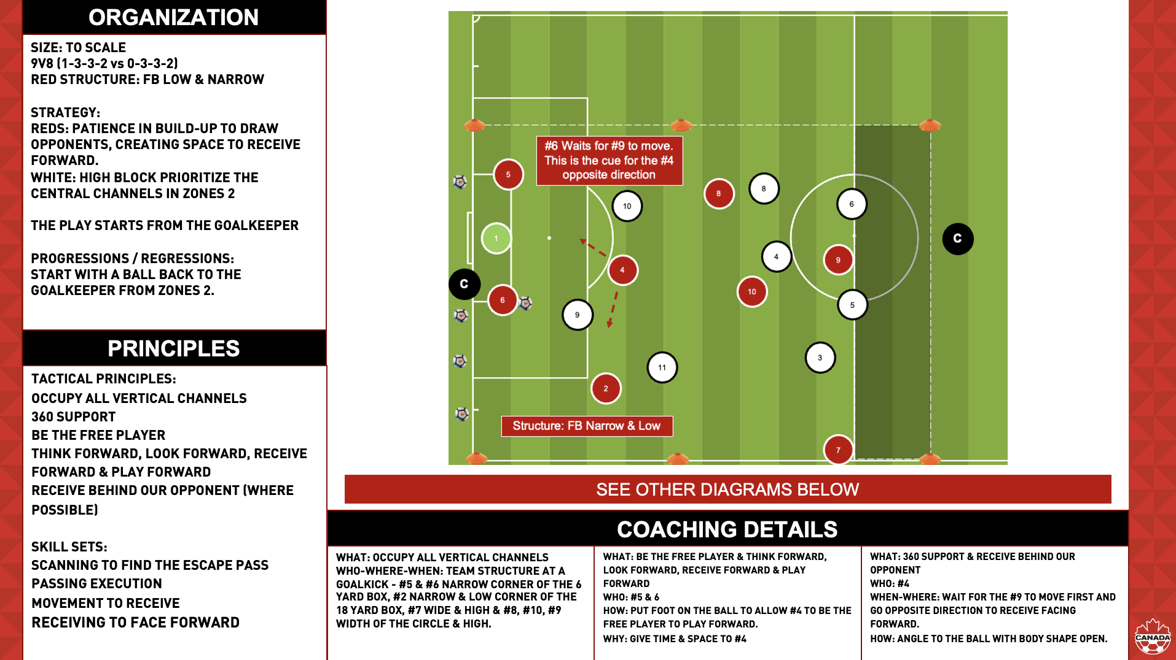

Practice Session 1
In the space below, insert your session plan details by selecting Insert > Image > Upload from Computer
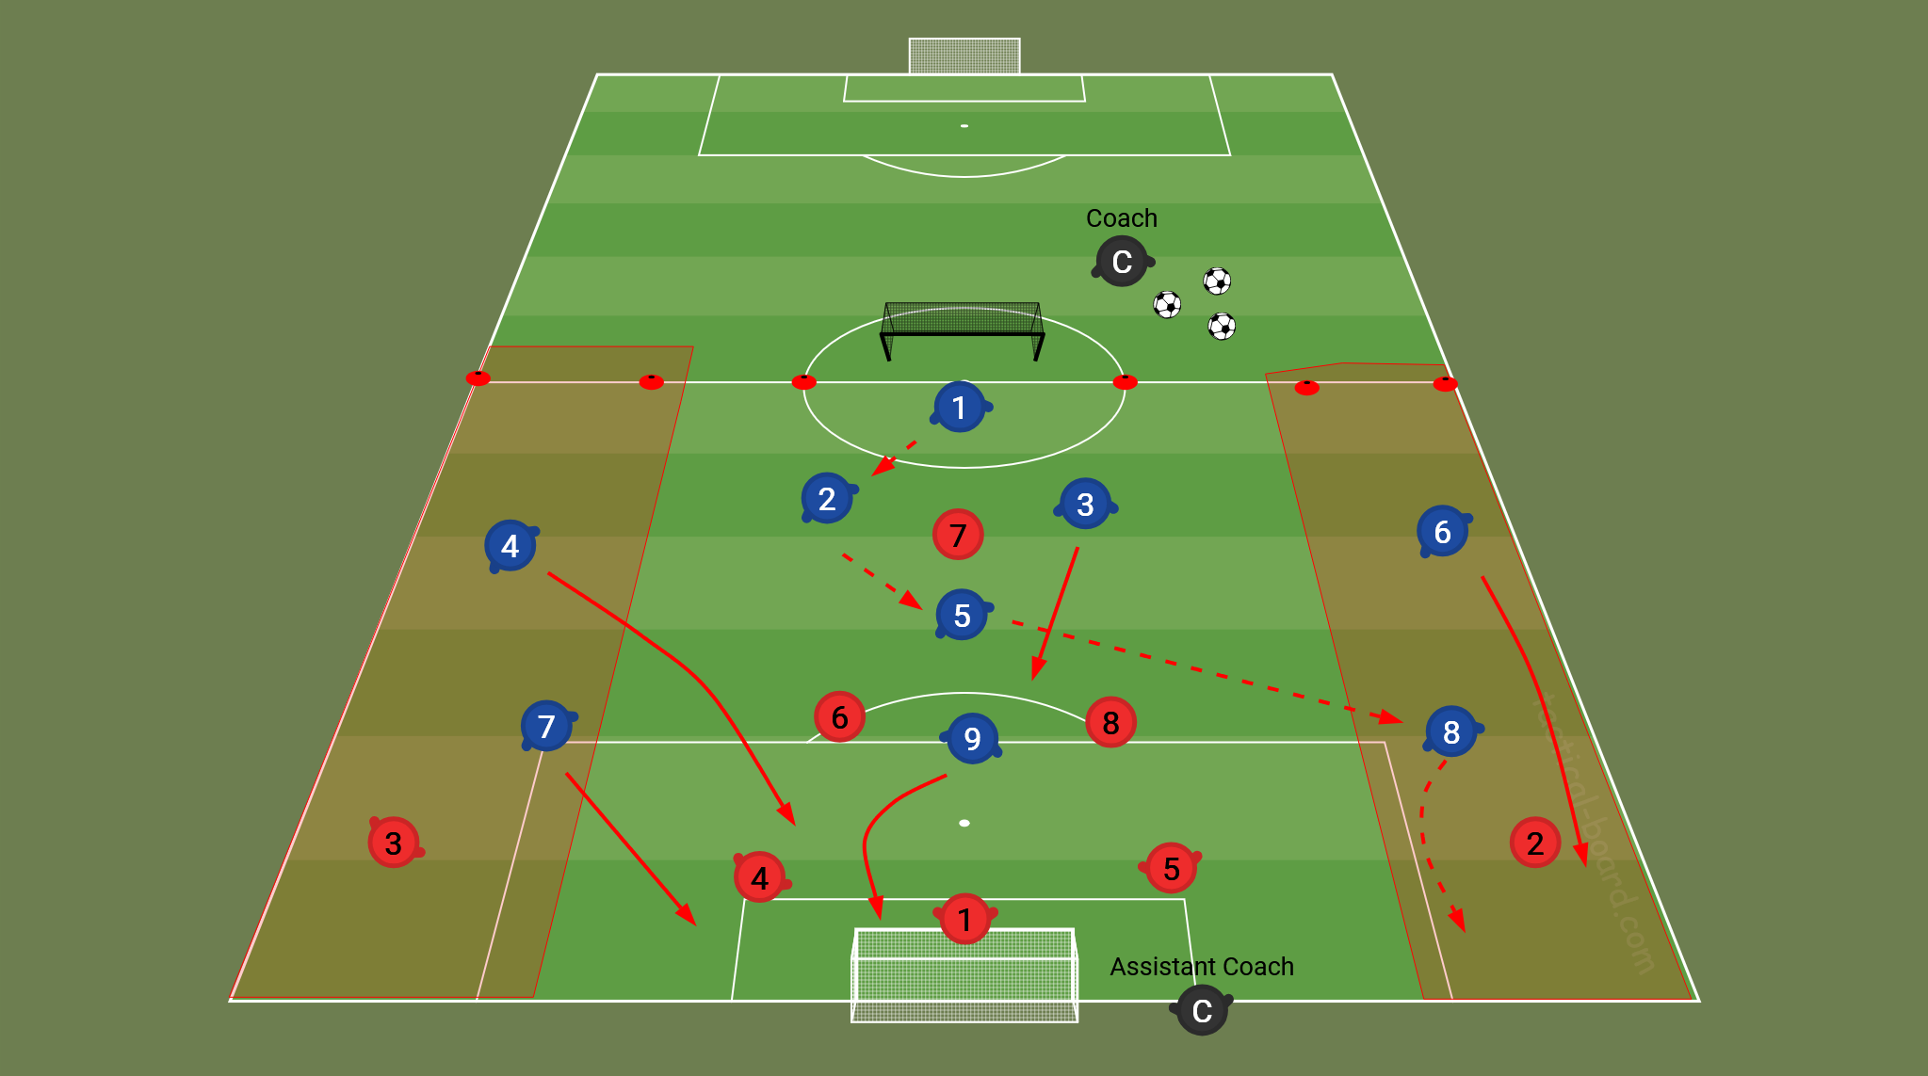

Practice Session 2
In the space below, insert your session plan details by selecting Insert > Image > Upload from Computer
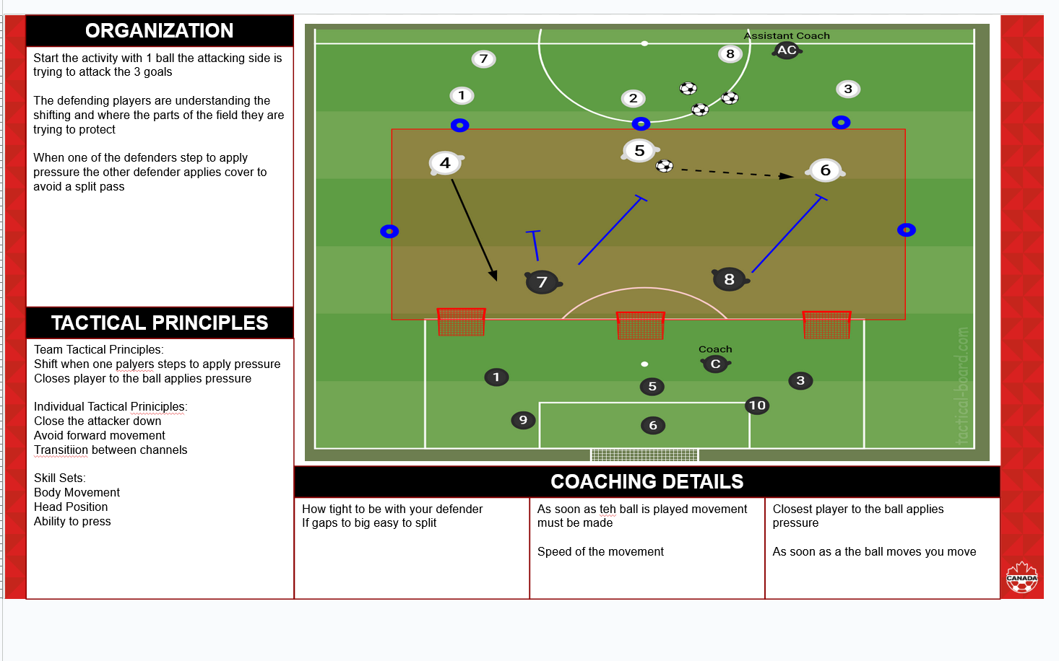

COACH DEVELOPER SUMMARY #1
Personal Goal Setting
0 to 1 year goal – how will you achieve becoming a League 1 U20 coach? What skill sets do you need that you might not naturally have as a former player?
1 to 3 year goals – what would be required to become an assistant coach vs. head coach? What steps would you need to take to accomplish this goal?
3 to 5 year goals – there is overlap of becoming a head coach within L1O that is within your 1 to 3 year goals. I can see your natural progression of U20 head coach to L1O assistant coach to L1O head coach to CPL assistant coach, but these goals are all dependent on position availability, experience, hiring process/selection, etc. and not completely within your control. How can you develop your skill sets and experience needed for each of these roles that is within your control? How realistic is it to achieve each of these goals within a 5-year period?
Action Item by October 31st, 2025: Read the material on Goal Setting: A Scientific Guide to Setting and Achieving Goals to add details, timelines, and strategies. Pick a strategy and breakdown how you will accomplish your goals.
Update: COMPLETED action item.
Personal SWOT Analysis
The goal of your Personal SWOT Analysis is for you to explore your strengths and weaknesses in detail, to outline the opportunities and threats that exist in your current and future environments, and to use this information to create a plan for successfully achieving your goals.
Action Item by October 31st, 2025: review your SWOT Analysis and create a plan for successfully achieving your goals. For strengths, what will help you achieve the goals? For weaknesses what gaps might exist in your current skill set, environment, experience that you need to consider improving and/or changing to reach your goals? What opportunities exist internally and externally to achieve your goals? What threats both internal and external exist that might prevent you achieving your goals?
Update: COMPLETED action item.
Module 1 – Welcome & Observation of Competency
Action Item by October 31st, 2025: In the Student Coach Diploma Handbook (https://friends-read-kce.craft.me/UvaJ1VhvUfTFKB) select Coach Education Principles if you scroll to the bottom you will see the five principles Curiosity/Accountability/Openness/Leadership/Teamwork. You can click on each and it will take you to a page that breaks down on-field and off-field behaviours needed to be successful in the course. Select 1 to 3 behaviours for each. Example – Curiosity – Clarity – 1 to 3 for on-field and 1 to 3 for off-field. You can tie these to your personal goal setting as well.
Update: COMPLETED action item. Excellent detail on personal goals for both on and off the field related to the Observation of Competency.
Module 2 – Developing the Creative and Adaptive Player
Recommendation would be to transfer your training design principles into your Game Model document as this is a component required within the capping project. Appreciate that you used the SCORE acronym from the course but added your own context within the details.
Action Item by October 31st, 2025: for the practice activity – add into session template (Slide 3) with organization, tactical principles, coaching details, and diagram. Any players not being used in the session can be removed from the diagram for clarity. Include your progressions that you discussed in the additional reflections. Consider how adding another player into the activity might enhance or remove game realism.
Update: COMPLETED action item.
Module 3 – Practice Methodologies & Advanced Activities
Like that you discussed that the coaching philosophy and motivation of players would influence the practice session methodology. Can you tie this to when you might use Progressive Method vs. Whole-Part-Whole and which one you prefer based on your current coaching environment and how this might change depending on age-stage of player.
Action Item by October 31st, 2025: for the functional – add into session template (Slide 3) with organization, tactical principles, coaching details, and diagram. Consideration for who is the server vs. your coaching position. We want you to be able to move and adjust your coaching position based on the play so do not have yourself be the server as well.
Update: COMPLETED action item.
Module 4 – Designing Your Game Model Part 1
Recommendation would be to add this Module into your Game Model document as these are components required within the capping project. Reminder there is also the Game Model Scratch Pad at the very end of the Coach Portfolio for you to use to begin developing your Game Model.
Moments of the Game – does not refer to the formations (systems) but attacking organization, defending organization, transitions (refer to slide 17 in the Reference Material for an example). Can you create your own based on your opinion of the moments of the game and how they are connected?
Pitch Geography – create consistency in your language within your style of play. You reference channels and zones with numbers but do not have these reflected in your diagrams. You have the systems (formations) you would play reflected here.
Systems (formations) – is what you have in pitch geography so you can move those diagrams to this section. When discussing positions find consistency in either using the name or number to reference (ie. #6 or holding midfield).
Action Item by October 31st, 2025: for the phase of play – add into session template (Slide 3) with organization, tactical principles, coaching details, and diagram.
Update: COMPLETED action item.
Module 5 – Transformational Coaching: A Complex Social Process
Good reflections on the realities of coaching individual players and how your intentions might affect what the player experiences/feels. Within the connection to my environment provide clarity on what you will START, what you will STOP, and what you will CONTINUE.
Action Item by October 31st, 2025: Review the module presentation and reference material slide 86 restate your START-STOP-CONTINUE based on the transformational coaching behaviours and the 6 Es (Engage, Explain, Exit, Enter, Educate, and Ensure)
Update: COMPLETED action item. Excellent reflection relative to the transformation coaching behaviours and 6 Es.
Module 6 – Understanding Tactical Responsibilities
This will be something you also build out within your Game Model document is the positional profiles of each player. There is an example in the Game Model Scratch Pad at the very end of this document you can reference.
Practice Session 1
Slide 1
System – consider stating systems for both team and opposition as well add a 1- for the goalkeeper (ie. 1-4-2-3-1)
Strategy – WHAT – the plan a team makes for a particular match or situation. (ie. Force the ball to their left side (channel 1) to force direct play.
Skill sets – refer to individual player actions or decisions
See slide 16-31 in the reference material for more information.
Slide 2
Players – assistant coach role should be under resources
Objectives & Learning Intentions – if your overall objective is looking to build from wide channels with combination play the first learning intention is redundant. Learning intentions should describe clearly what the player should know, understand, and or do. Consider the game scenario where they would need to play wide in the build as opposed to central. Instead of having to avoid playing the ball down the middle of the field, think about how players would make decisions to determine the best option is playing wide.
Tactical principles/skill sets can be transferred from slide 1 – based on what is written here can you combine this and create cohesion
Slide 3
Organization – should include pitch, parameter, players, re-starts, team systems if they have been adapted from the 11v11 system, how both teams score, strategy for both teams, primary/secondary players, progressions/regressions
Tactical principles – should be from slide 1 and show how they are being layered within the session. They do not all have to be within each activity
Coaching details – include WHO-WHAT-WHERE-WHEN-WHY-HOW – this can include system, tactics, and skill sets
Within the diagram – include coaching positions
*Remember goals represent a player that has been removed from the activity
Considerations:
- would a team scoring on the big goal without a goalkeeper create game realism or the appropriate challenge/competition for the players?
- Playing area for a 4v3 – is this space too large?
Slide 4
Refer to details from slide 3 as they would apply to this activity.
Considerations:
- Within the organization please provide clarity on if the defending team score they have a counter attack to try and score on the large goal?
- What happens if multiple players are shooting on the big goal at the same time?
Slide 5
Refer to details from slide 3 as they would apply to this activity.
Considerations:
- If there is no #9 on the green team who is going to create game realism for the #5 red since they do not have someone they will mark or might potentially stay high to provide depth. This could allow them to join the attack without the concern for defensive transition.
- Consideration for who is the server vs. your coaching position. We want you to be able to move and adjust your coaching position based on the play so do not have yourself be the server as well.
Slide 6
Refer to details from slide 3 as they would apply to this activity.
Considerations:
- What are the red zones and are there any restrictions?
Practice Session 2
Review notes from practice session 1 as notes regarding information and details required would apply.
Slide 2
Players- understanding when to shift from 1-4-3-1 to a compressed 1-4-2-3 would be the objective. Please review the systems as they should reflect 11v11
Objective & Learning Intentions should be connected to the moment of the game-strategy-tactics-skill sets as referred to in slide 1. This is also discussing attacking transition, which is not reflected in slide 1.
Slide 3
Considerations:
- If defending references are specific to one goal what could be a problem created by having them defend three goals? Especially when they are already overloaded in a 2v3
- You have them working on the press and cover within this activity but the objective is tied to working on a low block – how are these connected based on your strategy and tactics?
Slide 4
Considerations:
- The previous activity was 2v3. Why have you regressed to a 3v3 within this activity?
Action Item by October 31st, 2025: resubmit session plans with the notes listed above. Also ensure there is clarity on if you are using Whole-Part-Whole or Progressive Methodology. Refer to slide 39-43 in the Reference Material if needed. Diagrams should present a specific moment that aligns to the coaching points. Also include an overview of each activity including time.
Update: COMPLETED action item.

Module 7 - PLAYERS RIGHTS WHEN NAVIGATING SPORT
Date: | 2025-10-06
Facilitator(s): | Miranda. Matt, Dave
Module Summary:
SELECT ONE OF THE FOLLOWING ARTICLES FROM THE UN CHARTER ON THE RIGHTS OF THE PLAYER.

ARTICLE 12: RESPECT FOR THE VIEWS OF THE CHILD

ARTICLE 31: LEISURE, PLAY, AND CULTURE

IN YOUR OWN WORDS:

HOW WOULD YOU EXPLAIN THIS RIGHT TO A 12-YEAR-OLD SOCCER PLAYER?
Every child has a right to play. Play is so important to a child's development. They should be able to creatively explore and be able to explore their own interests in their sport.s every child has a right to develop in their chosen sports. We should provide an environment where they can have positive and supportive environments where all kids can learn and stay motivated to love sports. All kids should be treated equally regardless of their race, gender, ability.
RIGHT RESPECTED (THE "GREEN FLAG"):

DESCRIBE A SPECIFIC, REALISTIC SCENARIO IN SOCCER WHERE THIS RIGHT IS BEING CLEARLY RESPECTED AND UPHELD. WHAT DOES IT LOOK LIKE? WHAT ARE THE COACHES, PARENTS, AND PLAYERS DOING?
In our club we have 2 to 1, 2 coaches to one player any time a coach is speaking with a player in private. This is to protect the child and the coach to be sure that another individual is confirming anything that is said. This is also to protect the coach so that coaches can confirm that the conversation went the way it was said and that nothing was misinterpreted.
RIGHT VIOLATED (THE "RED FLAG"):

DESCRIBE A SPECIFIC, REALISTIC SCENARIO IN SOCCER WHERE THIS RIGHT IS BEING CLEARLY VIOLATED. WHAT DOES THIS LOOK LIKE? WHAT ARE THE POTENTIAL NEGATIVE IMPACTS ON THE PLAYER(S)?
We have had instances where coaches would treat players unfairly based on their attitude in training or other players are treating players unfairly and calling them names. Me as the coach at the moment had to have a word with the players and let them know that this is an abuse free environment. Here all players are free to make mistakes and learn and develop without ridicule from other players. This was something that had to be reinforced especially with young players who were still developing. Some of the negative impacts was that the player felt unappreciated and stopped attending training. In this case we had to have a meeting with the players and the players parents to confirm that the player will no longer face this type of ridicule when he attends training.
ACTION PLAN:

PROPOSE 2-3 PRACTICAL ACTIONS A COACH OR A CLUB COULD TAKE TO ENSURE THIS RIGHT IS ALWAYS PROTECTED.
One thing that our club has as stated above is a 2-1 rule where one coach must be accompanied by another coach when talking to parents or players. This is to reassure the importance of player confidentiality and to protect the coach in instances where information may come across the wrong way. Another thing would be an abuse free environment where players are free to make mistakes and players are not allowed to be rude or ridicule their teammates, making players on the team know that this is a safe place for players to learn and grow as players. This is a safe space environment and a place where players want to come and learn and continue to play and strive as a young player.

Module 8 - SAFEGUARDING & PROTECTING PLAYERS IN SPORT
Date: | October 9,2025
Facilitator(s): | Dave, Miranda, Mike
Module Summary: | Safeguarding in sports
TOPIC

ONE THING I FOUND VERY INTERESTING ABOUT THIS MODULE WAS...

A QUOTE FROM THE MODULE THAT STOOD OUT…
I found a very interesting Alison story and how the leaders in her space try to cover it up. Telling her that if she were to say anything then they would lose sponsorships and the team would not be. That was a way of putting a lot of pressure on a young player especially at that age and putting her in a very vulnerable position. I feel she is a very strong individual to come forward and do the right thing. I also now have a better understanding of the mental well being of players and why it is so important for them to get an idea of how to go about dealing with and nurturing a young mind.
MY OPINION

WHAT ASPECTS OF MY CURRENT OR PAST COACHING ENVIRONMENTS COULD BE CONSIDERED "NORMALIZED MALTREATMENT"? HOW CAN I ACTIVELY CHALLENGE THESE NORMS AND PROMOTE A HEALTHIER CULTURE?
This will help me with how I cope and how I talk to players. Screaming and swearing is not the best way to communicate. I should be able to communicate effectively with my players and let them know what is right from wrong in an organized and respectful fashion showing them the respect they reserve and keeping their safety and safeguarding the players at all times.
CONNECTION TO MY ENVIRONMENT

WHAT ARE THE SPECIFIC SAFE SPORT POLICIES AND PROCEDURES IN MY COACHING ENVIRONMENT? AM I FAMILIAR WITH THEM AND DO I ACTIVELY COMMUNICATE THEM TO ATHLETES AND PARENTS?
Yes, I believe every player has the right to a safe and respectful learning environment because this is where I feel players are able to strive the most. Having players that feel safe and are happy with their training provides players with the opportunity to learn and grow and become the best versions of themselves. As they grow we can continue to allow the players to understand the game and be able to grow into a great football player and also a confident human being who loves and can enjoy the sport for many years to come.

Module 9 - CONNECTED COACHING
Date: | Tuesday Oct 21, 2025
Facilitator(s): | Mike, Miranda, Dave
Module Summary: | Establishing a Coaching Philosophy
STEP 1: WHAT ARE YOUR VALUES & BELIEFS
My core values as a coach are honesty, accountability, empathy, and growth. These values guide how I interact with players on and off the field, how I make decisions, and how I respond to success and adversity.On the field, these values show up through clear communication, encouraging players to take responsibility for their actions, and creating an environment where mistakes are viewed as part of learning. Off the field, they guide how I listen to players, treat people with respect, and remain consistent and transparent in my decisions.My coaching philosophy is rooted in four core values: honesty, accountability, empathy, and growth. These principles dictate all my interactions with players, both on and off the field, and inform my decision-making processes, as well as how I handle both success and adversity.

My coaching values are demonstrated both on and off the field. On the field, I prioritize clear communication, encourage players to take ownership of their actions and responsibilities, and foster a culture where mistakes are viewed as vital steps in the learning process. Off the field, these values guide my interactions by ensuring I actively listen to player concerns, treat every individual with respect, and uphold a commitment to consistency and transparency in all decision-making.
STEP 2: WHAT DO YOU STAND FOR?
We stand for the beautiful game that is simple and where the ball is shared and moved around with a purpose. This is the football that I stand for and have high hopes of recreating. I’m more on the long term development of the player and not the result as we want to create football players for life and incredible human beings, winning games should just be the fulfilment of good habits.
STEP 3: GETTING CLARITY?
WHAT ARE MY OBJECTIVES?
WHAT DO MY PLAYERS NEED, AND HOW CAN I HELP THEM?
WHAT REPRESENTS MY MORAL STANDARDS AND INTEGRITY?
WHAT WOULD BE MY PERSONAL AND TEAM MISSION STATEMENT(S)?
WHAT ETHICAL AND INCLUSIVE FRAMEWORK UNDERPINS MY COACHING PHILOSOPHY?
My objectives as a coach would be to have a team of passing players that can transition from attacking to defending in a moment of the game. Where every player knows his role and his secondary role and are able to switch and manage other roles at different moments of the game. This is what my needs are from my players and ways that I feel I can help them achieve this is by going over moments where players have expectations. Expectations in the sense of are we trying to win the ball or are we trying to spread the field or are we trying to hold a lead. My morale standards and integrity the most represents me as a coach would be that players are enjoying the game and having fun while doing it. We want our players to enjoy their football but understand that there is trouble and not all moments of the game are exciting. There will be moments when we need to work hard and struggle through those moments and we will become stronger as a team.

My personal and team statement would be everything with a purpose. We are always doing everything with the purpose to improve our overall footballing ability. My team statement would be we win as a team and we lose as a team. Because as a team we compete and as a team we fail.

Some of the ethical and inclusive frameworks underpinning my coaching philosophy is that I want players playing for each other. I want an environment where players can learn and grow as players and not be afraid to make mistakes and be a place where they can learn from their mistakes and grow into a smaller and intelligent footballer.
STEP 4: WRITE A FINISHED VERSION OF YOUR COACHING PHILOSOPHY?
My intention as a football coach is to develop players that are in love with the game and that want to learn the game and improve in their overall footballing abilities. I want to create players that want to learn and are not afraid to ask questions and look for ways to improve. This is my philosophy as a coach and taking responsibility for my actions on how I would like to teach this to the players.
STEP 5: LIST YOUR CLUBS GUIDING PRINCIPLES BASED ON HOW YOU WOULD INTERPRET THEM?
My club's guiding principles are player centered. Meaning we always look to put the player forward and what can we do to improve the environment for the player.
STEP 6: IDENTIFY WHERE THE CLUBS GUIDING PRINCIPLES ALIGNS WITH YOUR COACHING PHILOSOPHY

OUTLINE IF THERE ARE ANY VALUES THAT CONFLICT?
The club's guiding principles align with my coaching philosophy because it is all about the players and ways that we can help them improve. We want this to be a way that we can have the players grow and make them the best player possible with the resources that we have.
STEP 7: ASK THE PLAYERS ON THEIR UNDERSTANDING OF THE CLUBS PHILOSOPHY AND YOUR COACHING PHILOSOPHY

HOW WILL YOU OPERATIONALIZE THE SHARED VALUES MAKING THEM VISIBLE IN YOUR COACHING AND INTERACTIONS?
My conversation regarding the coaching philosophy went well.They agreed that having a love for the game is important. They also agreed with part of my coaching philosophy, and gave notice that I try to make our training exercises and activities fun, no matter the intensity of the drill. They also had questions about the club's player centered principles and say they don’t feel like it is always that way in regards to player centered. But I ensured them that all decisions made by the club are player centred and focused on the development of the player. They also like that I constantly challenge them to become better players and allow them to ask questions, this makes them feel more involved in the session and this is something I intend to do more of to make them feel like they are contributing to the team goals. . They stated that me allowing them to ask questions helps them learn as players and provide me feedback that helps me tailor sessions that keep them engaged.

With the feedback I was provided I will continue to use it to my best ability and find better ways to engage the players and make them feel involved and that the drills/sessions are player centered.
STEP 8: HOW DOES ALL OF THE ANSWERS IMPACT THE DEVELOPMENT OR AMENDMENT OF YOUR WORKING GAME MODEL?
It just reassures me that focusing on the players is the best way to grow a team and as to grow as a coach. Having the player's interest in line makes it a lot easier to grow the player when the focus is on their development.
ADDITIONAL REFLECTIONS & NOTES
Knowing and having a game model is very important as a coach and making sure that the clubs philosophy and values are things that you align with as the two go hand in hand.

This is something that shouldn’t just be shared with the club but shared with the players as well so they always have an idea of what we are playing and what the intention of the coach is.

Module 10 - DEVELOP YOUR GAME MODEL PART 2
Date: | 2025-11-02
Facilitator(s): | Miranda, Mike, Dave
Module Summary: | Developing Game Model Pt. 2
USING THE VIDEO COMPLETE THE FOLLOWING INFORMATION FROM YOUR WORKING GAME MODEL:

MOMENT OF THE GAME
FIELD GEOGRAPHY
STRATEGY
CREATE ‘TACTICS’ TO SUPPORT THE STRATEGY
IDENTIFY THE REQUIRED ‘SKILL SETS’ TO EXECUTE THE ‘TACTICS’
Defending organisation without the ball. Defending when the opponent has the ball in zone 4. Transition from zone 4 -3 to 2. This is because they are pressing against a team that is starting with the ball from their goalkeeper. We are looking to force them to play wide and stay compact in the central part channels 3 and 2. We are looking to have the defender closest to the ball to apply pressure and the closing down the central channel.
Some of the skill sets required to execute the strategy is defensive tactic, applying pressure, moments of press. When to apply pressure and when to allow them to play the ball.
SUBMIT A COMPLETE SESSION PLAN ON HOW YOU WOULD INTRODUCE AND COACH YOUR DESIRED TACTICS - SKILL SETS

ADDITIONAL REFLECTIONS & NOTES
We want to focus on pressing attempts. It is important to run the curved run from the 9 as it prevents the defender from playing the ball back across the back line. It i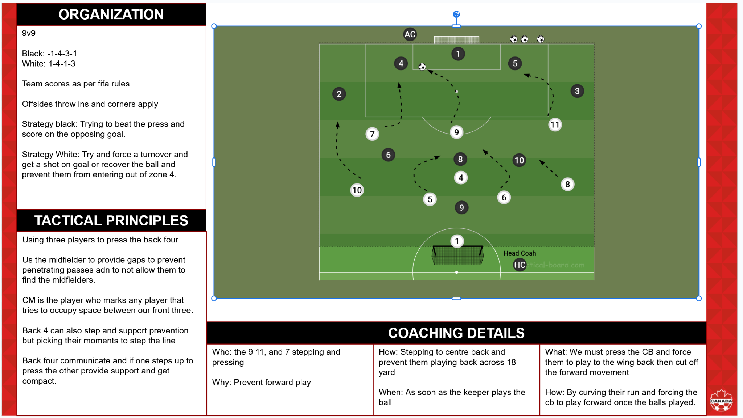It is also important to have these midfielders occupy the space in between their central players so that it's harder for the defenders to find line breaking passes. We must also step as a team meaning if one player steps the other defenders must get compact to cover the space that has been made by the pressing player. The front three must press with speed and prevent the forward ball. The success of the press will either be a turn over or an attempt on goal.

Module 11 - THE IMPACT OF PUBERTY
Date: | 2025-11-29
Facilitator(s): | Miranda, Dave, Mike
Module Summary: | Understanding biological process, how puberty and maturation impact players, explore the Youth physical development
SHARED CHALLENGES: FROM THE MATERIALS, LIST THREE CHALLENGES THAT ALL ATHLETES (REGARDLESS OF GENDER) MIGHT FACE DURING PUBERTY.
Not all players grow at the same time or at the same rate. Some players may hit their growth spurt earlier in life than other kids.
Kids who grow sports early might have a better chance at physical sports because they will be a lot stronger and have their strength and muscle development earlier.
In the 1976 Olympic Games even among the tall, it was the taller participants who won medals, showing that size does matter when it comes to performance sports. So you keep players who may not be as tall and motivated and have them work on speed and athletic ability especially against stronger players.

SPECIFIC CHALLENGES: FROM THE MATERIALS, DESCRIBE ONE SPECIFIC CHALLENGE RELATED TO THE MENSTRUAL CYCLE THAT A FEMALE ATHLETE MIGHT FACE.
One of the specific challenges of the menstrual cycle that a female athlete might face, is the low testosterone level when women are facing the first 7 days of their menstrual cycle. Testosterone is one of the main performance measurements in competitive sports.
WRITE DOWN ONE QUESTION YOU STILL HAVE ABOUT PUBERTY, THE MENSTRUAL CYCLE, OR THEIR IMPACT ON SPORTS.
How to deal with the adverse effects of puberty when preparing yourself for high level competitive sports. Especially younger players and women in particular.
THINK OF ONE INITIAL IDEA FOR HOW A COACH COULD BE MORE SUPPORTIVE TO AN ATHLETE GOING THROUGH THESE CHANGES.
I think that going over the athletic details of how the body changes and ow athletes bodies will change and that this is something that is normal and having the players prepared for this would be ideal as it would better prepare the player for the challenges their bodies are going through without having knowledge of why they might feel more tired than other days or why limbs hurt, or why they might see a shift in their overall performance at their sport.

Module 12 - TALENT IDENTIFICATION / DEVELOPMENT
Date: | December 10, 2025
Facilitator(s): | Miranda, Dave, Mike
Module Summary: | Talent identification and understanding the consequences of talent identification and selection. Acknowledging the limitation in talent prediction and shift focus from identification to development. Learning to mitigate the impact of selection on athletes and embrace the development approach.
TOPIC

One thing I found very interesting about this module was...

A quote from the module that stood out…
I found an 18 month old in the Netherlands that is able to kick the ball at only 18 months. For a kick to be able to execute such accuracy of kicking a ball into his toy box is incredible. Going to find out that the young boy was signed to a 10 year symbolic contract, which is incredible that they are being able to identify talent at such a young age.
MY OPINION

How does this presentation inform your approach to talent identification and athlete selection?
It helped me to understand that talent is more than just Physical, Mental, Psychological nor Cognitive-Perceptual and that is the reason why talent identification is so difficult especially at the early ages of development.
CONNECTION TO MY ENVIRONMENT

Considering the shifting focus from talent identification to development, how could your own training environment better support the development of all athletes, regardless of perceived talent level?
Taking this into consideration I have to be unbiased when it comes to players development as talent takes a long to develop. Also noticing certain biases like Relative age affect Socioeconomic status and geographic bias. These are so important to development because players need these things to develop, high performance coaching, ability to compete against high talent players and to be seen in front of more coaches and professional organisations in regards to opportunities for the athlete. Also I feel that some players are late bloomers and it takes certain players years to reach a high level where others who might peak early might fall off later in life, as they may not have the mental capability to perform at a high level for an extended period of time in regards to years and season.

Practice Sessions

Please upload two (2) full workouts you conduct with your team. Ensure that the following details are included:

- Session Objective & Learning Intentions
- Age and level of the players
- Moment of the Game
- System-Strategy identified for both teams
- Tactics-Skill Sets for the team you are coaching
- Resources
- Overview of each activity inc. time
- Progressions / Regressions
- Role of the assistant coach
- Coaching details (WHAT-WHO-WHERE-WHEN-WHY-HOW)
- Diagram that presents a specific moment and aligns to the coaching points

Practice Session Example
In the space below, insert your session plan details by:
Google Slides: Copy your Slides from the Session Plan Template > Click in the box > Paste > Link to Presentation
Microsoft Powerpoint: Take a screenshot of the Slide > Click in the space below > Insert > Image > Upload from Computer


Practice Session 3
In the space below, insert your session plan details by selecting Insert > Image > Upload from Computer
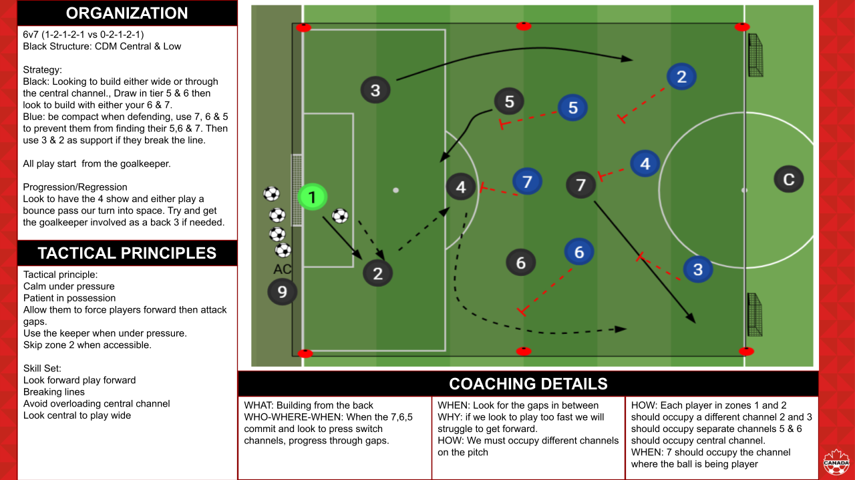

Practice Session 4
In the space below, insert your session plan details by selecting Insert > Image > Upload from Computer
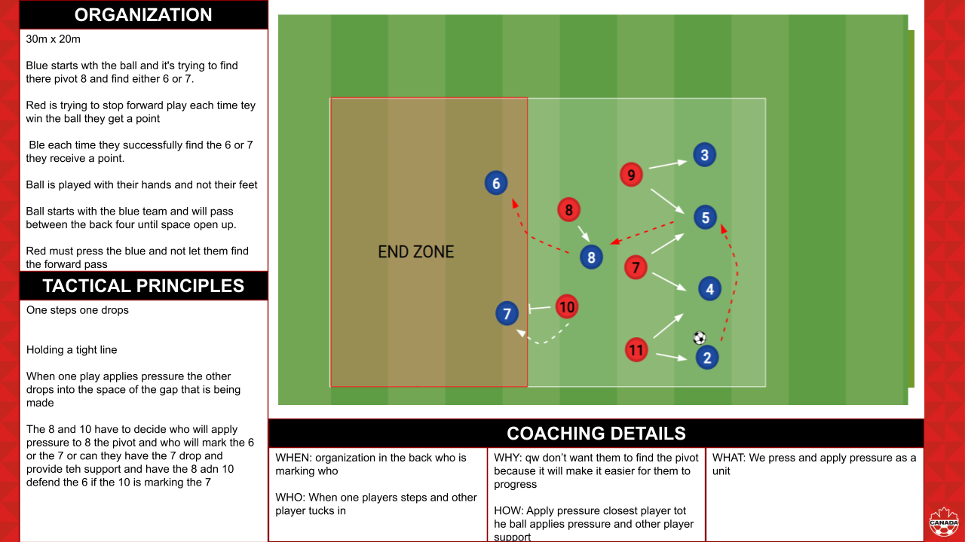

COACH DEVELOPER SUMMARY #2
Module 7 – Player Rights When Navigating Sport
You have some really good ideas related to Article 31, however, how would you explain this right to a 12-year old soccer player? What would you tell them to explain their right?

Can you provide clarity on how the Rule of 2 relates to Article 12 or 31?

I think it is excellent you are creating a safe supportive environment for the player(s). However, what, if any, is the club policy for reporting when you observe a coach abusing or mistreating players? Truly creating abuse free environments means holding coaches accountable to their actions through proper reporting systems and club accountability. If your club doesn’t have one this could be something you recommend and bring your concerns to the club leadership to address coach misconduct.

Module 8 – Safeguarding & Protecting Players in Sport
Review the questions connected with my opinion: WHAT ASPECTS OF MY CURRENT OR PAST COACHING ENVIRONMENTS COULD BE CONSIDERED "NORMALIZED MALTREATMENT"? HOW CAN I ACTIVELY CHALLENGE THESE NORMS AND PROMOTE A HEALTHIER CULTURE?
You have made some good comments regarding proper communication. But how are you promoting a healthier culture and challenging the norms that exist in sport?
Review the questions connected to Connection to My Environment: WHAT ARE THE SPECIFIC SAFE SPORT POLICIES AND PROCEDURES IN MY COACHING ENVIRONMENT? AM I FAMILIAR WITH THEM AND DO I ACTIVELY COMMUNICATE THEM TO ATHLETES AND PARENTS?

Again, some good comments regard to what you believe regarding a safe environment, however, what are the specific safe sport policies and procedures you have in your coaching environment (ie. Rule 2) and how do you communicate them with athletes and parents?

Module 9 – Connected Coaching

When it is asking about your values and beliefs it is referenced both on and off the field. Example: honesty, leadership, etc. Add in additional values that guide you as a person and coach not just how you want the team to play.

How do you focus on long-term player development as opposed to results? What does this look like in your decision making and environment created as a coach?

Excellent final coaching philosophy. I would encourage you to transfer this and other key components of the Connected Coaching module into your Game Model as this is a required component.

As stated in the module, ask the players on their understanding of the clubs’ philosophy and your coaching philosophy. You have stated that you will have these conversations, but we want you to ask the players and consider how you will operationalize the shared values making them visible in your coaching and interactions.

Action Item by January 31, 2026: have a conversation with your players on their understanding of the clubs’ philosophy and your coaching philosophy. Stated how you will operationalize the shared values making them visible in your coaching and interactions.
Update: COMPLETED action item.

Module 10 – Develop Your Game Model Part 2

Recommendation would be to add this Module into your Game Model document as these are components required within the capping project. Reminder there is also the Game Model Scratch Pad at the very end of the Coach Portfolio for you to use to begin developing your Game Model. Specifically begin to build out tactics-skill sets for each moment of the game and each phase of the moments of the game.
Practice Session Observations and Considerations:
Slide 1:
- How could you create clear sticky language for your strategy (ie. force wide/win wide).
- Would the closest player to the ball apply pressure be a strategy, tactic or skill set? Ensure you have a clear understanding of each. You have it both in strategy and tactic.
- Defensive cues – what would be the skill set?
Slide 2
- Primary players and secondary players – you have a duplicate of midfield. Consider it like this on the ball, around the ball, off the ball. On and around are primary based on the objective/learning intention. Around and off the ball are secondary based on the objective/learning intention.
- Resources – state the role of the assistant coach
- Objective – consider what might be the primary objective (ie. force wide and apply pressure on the backline when they are playing out the back) vs. secondary objectives (force the goalkeeper playing long and prevent them playing wide). Consider how the language could be contradictory force wide but deny them from playing in wide areas. Where do you want to win the ball? When do you want them to press? How do you want them to press?
- Tactical principles/skill sets – should be transferred directly from slide 1. Consider how you can take these ideas and apply it into the system-tactics-skill sets.
Slide 3 – state in organization this is the Warm-up
- FIFA 11+ is an injury prevention program. Provide clarity on which components of the program you are using within the warm-up.
Slide 4 – state in organization this is an initial SSG
- Systems must have brackets in the 11v11 system. The black team system would be a 1-4-2 as fullback would be considered part of the backline. Ensure you are stating them correctly to provide clarity to players on their roles.
- Consideration for pressing distances and roles within the full field game and how you will modify this within the initial small-sided game. Ie. in this the winger could press the fullback and double the centerback regardless of the game scenario based on the distances of the field dimensions.
- Clarity in positions – for black team you state fullback (organization) and wingback (coaching details).
Slide 5 – state in organization this is a functional
- Organization – state systems, strategies, scoring, progressions/regressions, starts/restarts, any modified rules
- Confirm they get a point regardless of scoring or they get an additional point if they score? Could a point be given if they press and win the ball as opposed to getting a scoring opportunity based on the objective.
- Would the opposite fullback for the black team be functional based on the reduced field?
- Layer the coaching details from the initial SSG into the functional.
- Begin to determine if you are using player positions as numbers or names as you are using both. Within your diagram begin to use the universal numbers for positions. Ie. fullbacks are 2/3 and centerbacks are 4/5.
Slide 6 – state in organization this is a final SSG
- Rationale for full width and reduced length if you are playing 9v9? Final SSG should have a similar field ratio to 11v11 depending on format.
Module 11 – The Impact of Puberty

Within the shared challenges – what are some specific challenges they will face during puberty? You reference the different in physical attributes after puberty and being tall. Please go back and list challenges during puberty regardless of gender.

Like that you are going to speak with them about how their body changes through puberty and how it might impact performance. I want you to go one step further and think how this might influence how you would coach. How would you adjust planning and coaching within your practice and games based the impact of puberty.

Module 12 – Talent Identification/Development

Why did that quote standout to you and how did it influence your thinking on talent identification?

From your opinion, if talent identification is more than Physical, Mental, Psychological or Cognitive-Perceptual, how has this module influenced your approach to talent identification and athlete selection?

Would encourage you to calculate the Relative Age Effect of your team – how many of them are born within the first 3 months of the year. From this information how will you reconsider player selection and development? How could your own training environment better support the development of all athletes, regardless of perceived talent level?

Practice Session #3 Observations and Considerations:
Slide 1 – ensure this begins to align with your Game Model.
- System – include attacking organization and defensive organization systems. This does not align with your Game Model. What is the rationale?
- Skill sets – are the technical actions of the players.
- Zones/Channels – need to align to your Game Model. Begin to use the same language.
Slide 2
- Resources – should include role of the assistant coach and timeline for session
- Objective and learning intentions – what will the players learn? Write these through the lens of the players learning.
- Tactical principles (tactics)/skill sets – should come directly from slide 1. Combine slide 1 and slide 2.
Slide 3
- State what part of the session this is within organization
- What is the purpose of the handball as tied to the objective/learning intentions?
- What is the scoring system?
- Are there progressions/regressions?
- How many groups based on 18 players? Minimum of 2 groups, with potentially 2 players not participating based on diagram numbers
- Tactical principles are from slides 1 and 2 – you can state them all or which ones are most relevant to the activity and you want to focus on
- Coaching details – where should be in relation to the activity not pitch geography as it is not relevant based on the organization; missing WHO; drag defenders to create space is a what – how would be how they drag defenders to create space ie. single vs. double movement
Slide 4
- State systems for the small sided game, including 11v11 ie. 1-2-1-1 (1-4-3-3)
- What is the strategy for both the attacking and defending teams?
- Coaching details are the same as previous – throughout the session they should be layered depending on the activity and added complex
- Tactical principles are from slides 1 and 2 – you can state them all or which ones are most relevant to the activity and you want to focus on
Slide 5
- System should be an adaptation from the systems stated on slide 1 – both theses based on the diagram have a diamond midfield which is not consistent with the system on slide 1. Clarity on which team the system applies to
- How could you potentially vary the restart to change the scenario and bring out different pictures for the players?
- Your strategies became fixed positional situations, can you make them more principle-based?
- Coaching details – your stated WHEN – looking for gaps in between is WHERE; your HOW – occupy different channels on the pitch is also WHERE. WHO – player on the ball, around the ball, away from the ball; WHERE – relative to pitch geography or spaces; WHEN – based on opponent, ball, or pitch geography; WHAT – tactics/strategies; HOW – are they going to execute the tactics/strategies; WHEN – timing
- Tactical principles are from slides 1 and 2 – you can state them all or which ones are most relevant to the activity and you want to focus on
Slide 6
- System – state adapted system and 11v11 system in brackets with clarity on which team the system applies to
- Opponent strategy should create the soccer problem for the objective/learning intentions
- Final small-sided game – FIFA rules. Restarts should be consistent with FIFA rules.
- Progression – how could you modify the opponent to increase the challenge before putting players on a touch restriction?
- Ensure coaching details are tied to the objective/learning intentions. Begin to introduce 1v1s in wide areas which has not been in the rest of the session or overview slides
- Tactical principles are from slides 1 and 2 – you can state them all or which ones are most relevant to the activity and you want to focus on

Practice Session #4 Observations and Considerations:
Slide 1 – ensure this begin to align with your Game Model.
- Zones/Channels – clarity on zones. Zone 4 is your own goal. Zone 1 is the opponents goal
Slide 2
- Tactical principles (tactics)/skill sets – should come directly from slide 1. Combine slide 1 and slide 2.
Slide 3
- Rationale for playing handball as opposed to soccer?
- Does blue have to play through the 8 to progress to the 6 or 7? You want to create habits based on defending tactical principles. If the opponent has to play the same pattern every time they can begin to cheat and not recognize the right moments to press vs. cover underneath.
- What happens when red wins the ball? What is their next action?
- What is the scoring system?
- How would you progress or regress?
- Coaching Details: WHO – player on the ball, around the ball, away from the ball; WHERE – relative to pitch geography or spaces; WHEN – based on opponent, ball, or pitch geography; WHAT – tactics/strategies; HOW – are they going to execute the tactics/strategies; WHEN – timing
- Tactical principles are from slides 1 and 2 – you can state them all or which ones are most relevant to the activity and you want to focus on
Slide 4
- System – state adapted system and 11v11 system in brackets
- Clarity on funnel and how it relates to switching the point of attack
- Based on slide 1 strategy is to force the opponent long and press the first line forcing long balls – this should be consistent throughout the session
- Tactical principles are from slides 1 and 2 – you can state them all or which ones are most relevant to the activity and you want to focus on
- What is the pitch/parameters? Area size. What is the red zone in the diagram?
- How would you progress or regress?
- Coaching Details: get into the details based on your Game Model and the session objective/learning intentions. This will guide your coaching and how you support players in understanding
Slide 5
- System – state adapted system and 11v11 system in brackets
- When red wins it and gets a point – does play continue with them looking to score on the goal?
- How does blue score? Rationale for another goal and goalkeeper based on objective/learning intentions. How could this impact the attacking (blue) team from playing long?
- What are the progressions/regressions? Consider how you would modify the opponent to increase or decrease the challenge
- Tactical principles are from slides 1 and 2 – you can state them all or which ones are most relevant to the activity and you want to focus on
Slide 6
- System – state adapted system and 11v11 system in brackets
- Tactical principles are from slides 1 and 2 – you can state them all or which ones are most relevant to the activity and you want to focus on

Module 13 - MENTAL HEALTH IN COACHING
Date: | January 2, 2026
Facilitator(s): | Dave, Mirande, Mike
Module Summary: | Mental Health in Coaching
TOPIC

ONE THING I FOUND VERY INTERESTING ABOUT THIS MODULE WAS...

A QUOTE FROM THE MODULE THAT STOOD OUT…
One of the quotes that stood out to me was how coaches play such a big role in young athletes. Explaining to them that it is also fun and not just winning and losing. And how journaling and meditation can help them with their journey wherever it is in football. Also I found that “ If kids stop enjoying the game, development stops” resonates strongly with me as it touches on the discussion of youth dealing with pressure and keeping a level of enjoyment with the game.
MY OPINION

THINK ABOUT YOUR OWN COACHING EXPERIENCES. WHERE DO YOU SEE OPPORTUNITIES TO BETTER SUPPORT THE SOCIAL-EMOTIONAL DEVELOPMENT OF YOUR ATHLETES?
I think meditation and journaling, because if players are only seeing development in the area of winning and losing, then journaling can help them achieve small personal goals that can help them grow as a player and individually apart from the team. This is also where they can find ways to make sure they are pushing themselves, and make sure that they are at the top of their game. Even visualization and taking a moment before games and before practice to see what a good session looks and feels like.
CONNECTION TO MY ENVIRONMENT

WHAT ARE SOME SMALL, PRACTICAL STEPS YOU CAN TAKE THIS WEEK TO CREATE A MORE POSITIVE AND SUPPORTIVE ENVIRONMENT FOR YOUR ATHLETES?
I think journaling is so important as this is something that I did as a player, but as I’m working with young players who may not understand the importance of journaling I believe that this might be something that is hard to get them to buy in on. But me being a player who journaled i was constantly able to see improvements in my game by journaling and seeing my progress as a player and how it helped me improve. Even visualization, possibly before a game, go over some things that we worked on in training and see if we can visualize ourselves doing these things in the game ahead of our match.

Module 14 - COACHING DURING TRANSITIONS OF ADOLESCENCE
Date: | Tuesday December 30, 2025
Facilitator(s): | Miranda
Module Summary: | The challenge of Coaching through transitions of adolescence
TOPIC

ONE THING I FOUND VERY INTERESTING ABOUT THIS MODULE WAS...

A QUOTE FROM THE MODULE THAT STOOD OUT…
One thing I found interesting was the peer comparison as this is something that I notice amongst my players. They become teenagers and are constantly evaluating themselves in relation to others - such as friends and teammates - with a biased perspective. This is something that I notice with my players as they want to fit in and not feel left out and get very emotional at times other than the older boys that I coach that are in their late teens.
MY OPINION

IDENTIFY A MINIMUM OF THREE STRATEGIES YOU CAN IMPLEMENT AS A COACH TO BETTER SUPPORT GENERATION Z ATHLETES UNDER YOUR CARE.
One thing I can do is try to relate to my players and make them feel comfortable and try to let them know that I understand how they are feeling and what they are going through and letting them know that I can support them.

Also I can let them know that if they ever need to speak to me about anything or they are having a bad day and what to take some time to themself than they can take that time to do so. This is a major thing as we want our players to be able to train in a safe place where they can learn and become better players and give them the best opportunity to grow as a player.

Lastly I would want them to be understanding of how they treat their peers and make sure they are always being kind and respectful to their teammates and how we treat each other, maybe a lot of team bonding events so that they can continue to grow as a team and not become divided at all.
CONNECTION TO MY ENVIRONMENT

CONSIDER HOW YOU CAN MODIFY A BASIC 4V4 SSG TO INTENTIONALLY FOSTER THE DEVELOPMENT OF THE 4C’S

LIST 2-3 FOR EACH CONFIDENCE - COMPETENCE - CHARACTER - CONNECTION
Three ways that I can modify a SSG 4v4 to intentionally foster the development of the 4 C’s are:

Confidence I can rotate positions during the 4v4 so players experience success in different roles, helping them feel capable beyond one position. I can also use simple challenges for example a point for trying a 1v1 or switching play to reward effort and decision making, not just goals. Also we could provide short, specific encouragement during natural breaks in play to reinforce what players are doing well.
Competence I can adjust the pitch size and rules such as a touch limit or required passes to challenge players technically and tactically at the right level. Use guided questions during stoppages like what helped you keep possession there and to support learning and problem solving. Also we can keep the game flowing allowing repetition and learning through play rather than constant instruction.
Character: We can build rules into the game that promote respect, such as self referring fouls or restarting play or calling the ball out when it goes out of bounds. Reward positive behaviour in communicating and helping teammates and honesty, with bonus points for teams. Addressing mistakes calmly and consistently to model emotional control and respect others.
Connection: We can mix teams regularly so players work with different teammates and build relationships across the group. Including quick team huddles between rounds where players discuss one thing they did well together and encourage communication by setting simple team based challenges like all players touching the ball before scoring.

This was very helpful especially because this is the age group that I'm currently working with U15 U17 U18 .
ADDITIONAL REFLECTIONS & NOTES

Module 15 - MENS EXCEL PRESENTATION
Date: | January 30, 2026
Facilitator(s): | Miranda, Dave, Mike
Module Summary: | Men’s Excel
TOPIC

ONE THING I FOUND VERY INTERESTING ABOUT THIS MODULE WAS...

A QUOTE FROM THE MODULE THAT STOOD OUT…
I found the rhythm and how we focus on different areas of the pitch to progress, especially the Draw to exploit impact. If you know how the team plays you can force build up to a certain way and really shape how we look to play out the back having the whole team on the same page.
MY OPINION

WHAT ARE THE POTENTIAL LIMITATIONS OR CHALLENGES OF IMPLEMENTING THIS TACTICAL IDENTITY? HOW MIGHT OPPONENTS COUNTER THESE TACTICS?
If a team has studied our game play and knows how we play. We may get caught in transition moments or have trouble breaking out front he back if they have studied our tactics and implemented a way to bypass our defense. This could be hard to adjust in a match so we would likely have to have an idea of how to make changes within the game if this does happen.
CONNECTION TO MY ENVIRONMENT

HOW DOES THIS TACTICAL IDENTITY COMPARE TO MY CURRENT VIEW OF THE GAME? WHAT ARE THE SIMILARITIES AND DIFFERENCES?
This is very helpful as I am not used to this level of detail to the game as I’m usually coaching players who need more focus on the basic things of the game. In regards to pass and game understanding. Where it is a bit challenging to really focus on strategic tactics in the game. But I find it interesting how Excel level players set up their team and how everyone is on the same page.

Some of the similarities are the way he structures his team in regards to defensive organization and attacking organization. The other thing that is similar is the direction that they are representing players playing in certain roles. This is something I implement to my coaching philosophy.

Some of the differences that I explain in my opening statements is the attention to details, again this is for an excel program where with my group I look to focus on the basics in football and nothing too technical as my team is not at that level yet.

Module 16 - WOMENS EXCEL PRESENTATION
Date: | January 30, 2026
Facilitator(s): | Miranda, Dave, Mike
Module Summary: | Womans Excel Presentation
TOPIC

ONE THING I FOUND VERY INTERESTING ABOUT THIS MODULE WAS...

A QUOTE FROM THE MODULE THAT STOOD OUT…
We need to be more relentless, when she was going over the game observation of the game against Portland. That really resented me because this is how I feel conversations after tough matches with my team about how they need to go. It was also exciting seeing some of the details for competing in the Champions League against top talent in the world.
MY OPINION

HOW IMPORTANT IS CONSISTENCY IN TACTICAL MESSAGING AND TRAINING, AND HOW CAN I MAINTAIN IT THROUGHOUT THE SEASON?
Consistency in tactical messages is important because you want players to know their position and understand and see what we expect from them. This is something that we can iterate in training sessions and in personal development sessions that I have with the player where I go over the responsibility of their role. This is also helpful so that they can continue to learn their position and become a smarter and more efficient player on the field.
CONNECTION TO MY ENVIRONMENT

WHAT ARE THE SPECIFIC AREAS WITHIN MY TEAM'S CURRENT TACTICAL APPROACH THAT COULD BENEFIT FROM THESE INSIGHTS?
I think my defensive transition will give my team a better understanding of how we defend and who should be where and doing what, but the specific details exactly as to why certain players are expected to do what and why. Also how like we went over in our coaching methodologies.

These specific details would be very helpful in letting our team know how to be better aware tactically for our weekend fixtures.

Module 17 - TRANSFORMATIONAL COACHING DURING THE MATCH
Date: | February 22, 2026
Facilitator(s): | Miranda, Dave, Mike
Module Summary: | Transformational Coaching behaviours in the context of a match.
MY OPINION

IDENTIFY POTENTIAL LEARNING GOALS FOR PSYCHOLOGICAL & SOCIAL CORNERS INCLUDING STRATEGIES AND BEHAVIORS THAT YOU MIGHT CHALLENGE A PLAYER IN A MATCH.
I might challenge my player to keep his cool in a challenging situation or if a player is really trying to trigger him . Letting him know that players that are able to keep their cool in challenging situations fairs better than players who tend to lose their cool. And how players like that are usually leaders of the team and challenge them to be a leader.
CONNECTION TO MY ENVIRONMENT

REFLECT ON HOW YOUR PRACTICAL EXPERIENCE WENT WITH EXECUTING YOUR OWN MATCH PLAY CONNECTED TO THE PLAYERS INDIVIDUAL DEVELOPMENT PLANS.

REVIEW YOUR AUDIO AND ANSWER WHAT YOU WILL START-STOP-CONTINUE TO DO.
I communicated with my player that he needs to take more shots and we created as he is a great striker of the ball but doesn’t do it much in games. I will start by explaining that I believe he has a good shot and encouraging him in training and before games.

What I will stop is reiterating myself in games, over and over, giving the players time when I take them off the field to give them instructions on what I would like them to do in the game.

What I will continue to do is to encourage them during half time whether I like what they are doing or If I can find moments where they can do what I'm asking them to do better.

I remember we had a big match coming up against a rival team where one of our previous players had left our team to go and play for vaughan and he was friends with many of the players on the team I was coaching at the time. I had gone over certain tactics and built up the match as a rival match just to get a response from the team. By the end of the week players were coming up to me telling me how excited they are to play this match and how they will be doing and executing the preparation plans that we made. We went on to beat the team and it was the execution of our game plan to counter quick when they committed their midfielders forward.
Another instance was when I was playing 6v6 indoor in the PISL and we had to play Bradford Wolves who had gone the whole season undefeated. I went over our finishing over and over again in a specific way. I had the mannequins set up a specific distance in front of the goalkeeper. And I remember this instance because one of the players had complained to me that the distance was too close and did not provide them enough space to find their target. I refused to move the mannequin and told them this is how the Bradford Wolves tend to play. In the match we came very close to spoiling their undefeated season, but we lost 4-5, we scored a goal from exactly the play that we had been working on in training within the first 5 minutes of the match. This connected with the players individually because at that moment they understood what I was planning for.

ADDITIONAL REFLECTIONS

Module 18 - COACHING IN A MATCH: ADJUSTMENTS TO SUPPORT PERFORMANCE
Date: | March 1, 2026
Facilitator(s): | Miranda
Module Summary: | Presented our project
TOPIC

ONE THING I FOUND VERY INTERESTING ABOUT THIS MODULE WAS...

A QUOTE FROM THE MODULE THAT STOOD OUT…
One thing I found interesting was the scenario that we are challenged with in the nearpod and how we addressed the issue at hand. One part from the module that stood out was the attacking Organization and Defending organization. Also the scouting report as at our level we rarely get to scout a team as there is usually not much footage of teams playing that are publicly accessible. I found it interesting that the coach had added so much detail and was very specific in what he wanted to get across to the players at half and what information he decided to leave out.
MY OPINION

IN MY OPINION...

FROM MY OWN EXPERIENCE...

IN MY OWN LIFE...
In my opinion when incidents happen with players on the field I have to address it. I try to be calm and maybe change the player who is causing the problem and just have a word with him. This is something that has helped me in the past and I find I can desescalate the problems at times.

I have made similar adjustments when we had played in a game and had gotten a red card, at half time I had to go over our formation and the readjustments that we were going to make based on how the other team was playing. We had to play a little more compact and not commit too many players forward. I also spoke with our goalkeeper and encouraged him to slow the game down when we could as we wanted to slow the moment of the other team as they had numerical advantage and we were working on tired legs.

Overall my team adjusted well and we were able to walk away with a tie after being down for 45+ minutes. I think the tactical adjustments that I made at half time really helped us walk away with some points from that match.

CONNECTION TO MY ENVIRONMENT

THIS CONNECTS TO MY ENVIRONMENT AND COACHING BECAUSE…
This connects to my environment because I constantly have to deal with players who are dealing with personal issues and I have to find ways to keep them calm and be respectful with their teammates and the ref. All our teammates have to feel respected or else we cannot play successfully as a team.

Module 19 - BUILDING A MATCH PLAN
Date: | March 20, 2026
Facilitator(s): | Miranda
Module Summary: | Building a match plan and specific details regarding the match.
TOPIC

ONE THING I FOUND VERY INTERESTING ABOUT THIS MODULE WAS...

A QUOTE FROM THE MODULE THAT STOOD OUT…
One thing I found interesting about the module was the warm up preparation for international duties. How they had the pre meeting where they go over the line up and moment to moment on the field to build up to the match. Also the moment when he goes over the F1 pit stop where they have a team of pit stop crew members that are able to execute their plan at a moment's time.
MY OPINION

HOW MIGHT CREATING A STRATEGY ASSIST THE PLAYERS BUT ALSO REMOVE ANY CHALLENGES FOR YOU AS A COACH?
Having a strategy is very important because it provides the player directions. It also gives them the best opportunity to be prepared for the match and go into the game with an understanding of how we’d like to play. I also need to give them an opportunity of any strategy that they may have going into the upcoming match. It also removes challenges for me as a coach as I can focus more on the match if I have taken care of all the specific details pertaining to the match.
CONNECTION TO MY ENVIRONMENT

REFLECTING ON YOUR OWN COACHING ENVIRONMENT, WHAT IS ONE KEY AREA WHERE YOU COULD ENHANCE YOUR MATCH DAY PREPARATION TO IMPROVE PERFORMANCE, AND HOW MIGHT YOU PRACTICALLY IMPLEMENT THAT CHANGE?
One thing would be my pre match preparations in regards to what we want to get done before the match. From the time we arrive up until the moments before the game up until kick off. Even regarding half time and what input my Assistant Coach has for me. He said his eyes in the sky, where he talks about the other staff watching the game from different view points.

Module 20 - DEVELOPING A MICROCYCLE
Date: | March 3,2026
Facilitator(s): | Miranda
Module Summary: | Understanding the training load model, and assessing the team and individual needs based on the game model. Establishing development appropriate practice sessions and objectives and learning intentions aligned with the development of the game model in the cycle.
MY OPINION

WHAT ARE THE MOST IMPORTANT ELEMENTS TO CONSIDER WHEN DESIGNING A TRAINING LOAD MODEL?

WHAT COULD BE THE MOST EFFECTIVE WAYS TO MEASURE AND TRACK TRAINING LOAD WITH YOUR AVAILABLE RESOURCES?
Some of the most important elements to consider when designing a training load model are the amount of matches and how spaced matches are.Knowing this and planning your session accordingly are a way to keep players healthy and injury free.
For me and my team the most effective way is to have conversations with the players and consistently ask them how they are feeling and if they are eating and stretching correctly. Also I can assess that at games and at training, if a player has picked up a knick or a kick. Maybe he needs to take a week off of training to recover or some rest and recovery period at training just to stretch.
BUILD A MICROCYCLE + PRACTICE SESSION

Google Slides: Copy your Slides from the Session Plan Template > Click in the box > Paste > Link to Presentation
Microsoft Powerpoint: Take a screenshot of the Slide > Click in the space below > Insert > Image > Upload from Computer
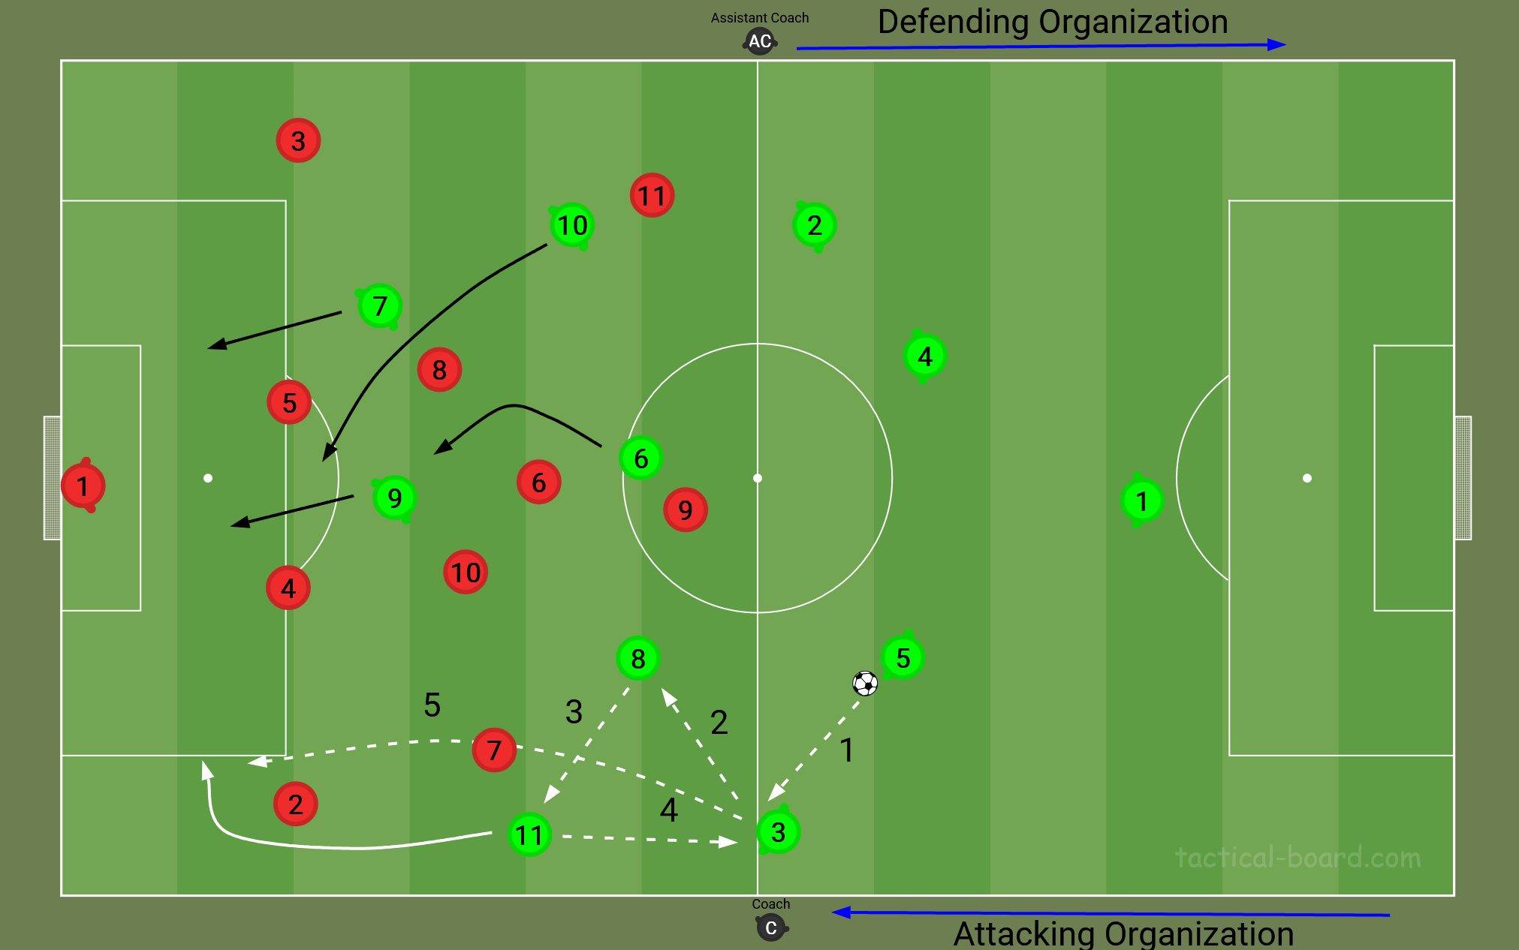

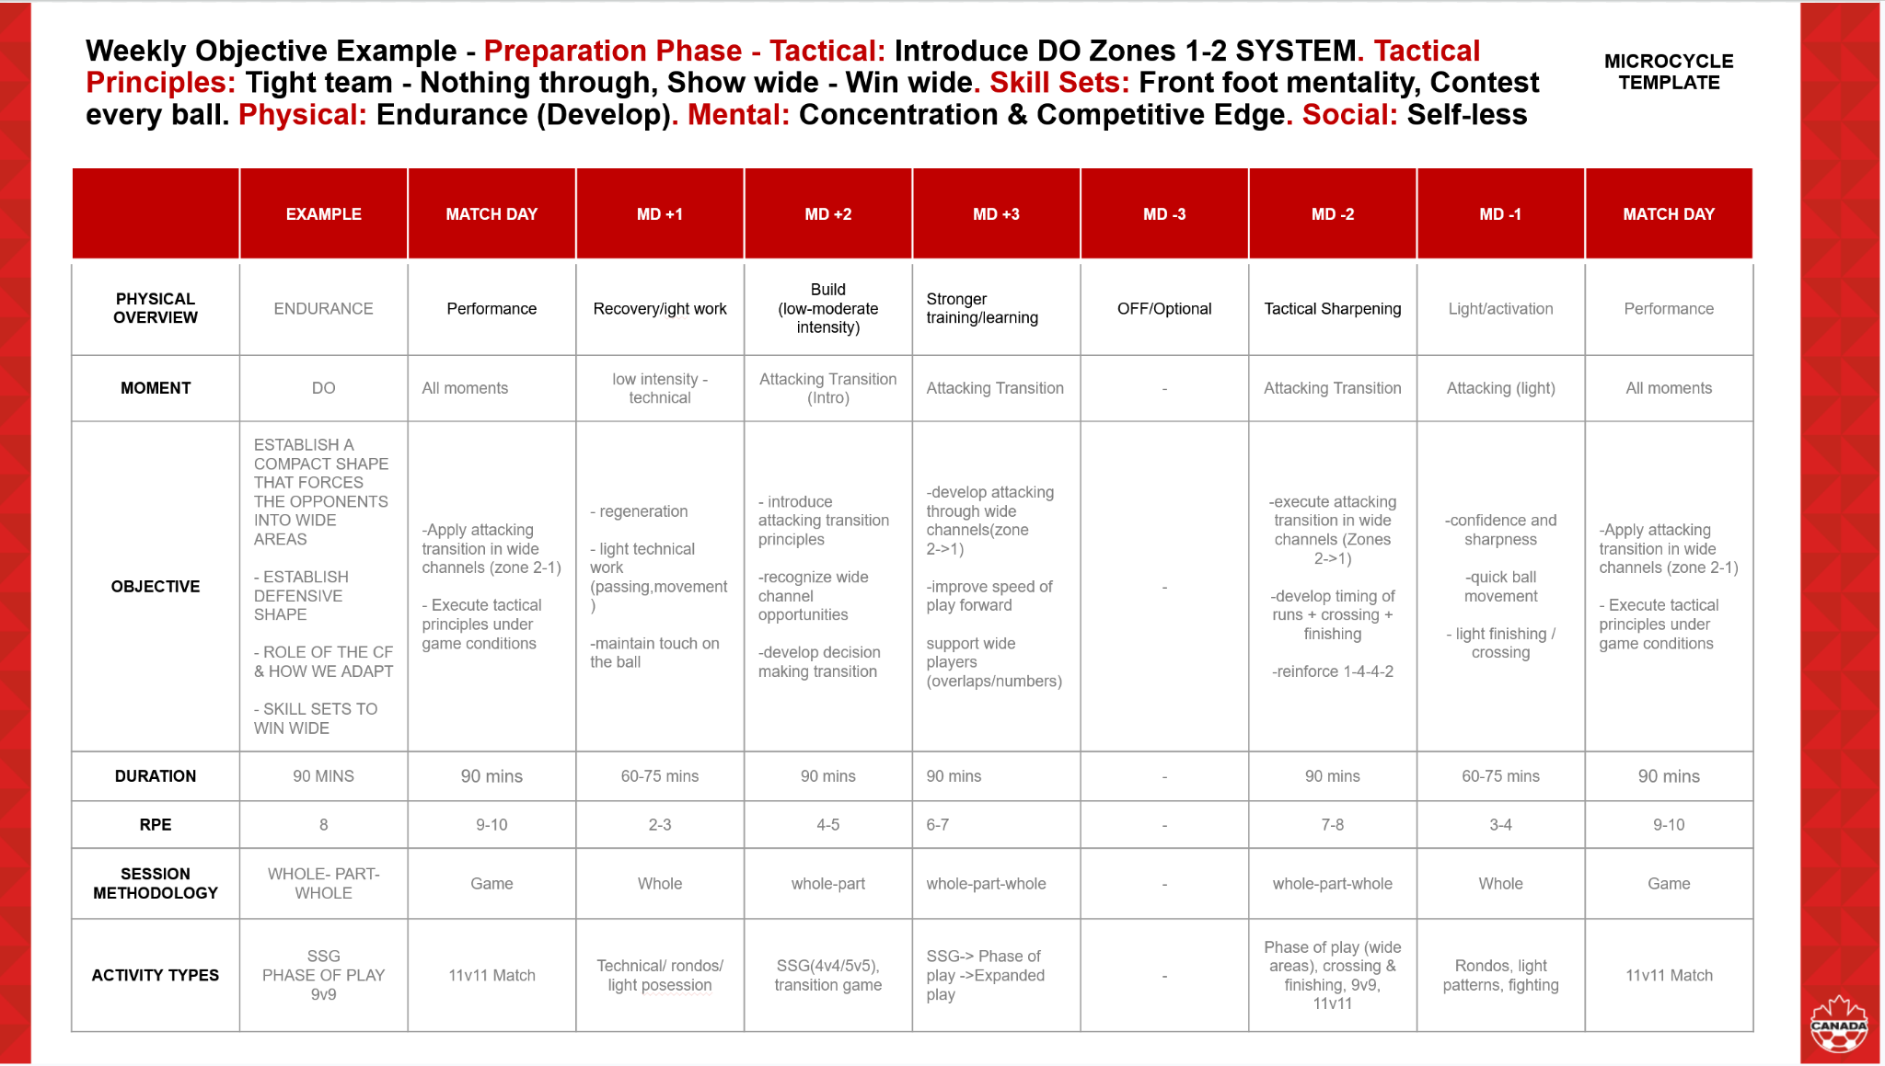
ADDITIONAL REFLECTIONS & NOTES
This was helpful as this is what I have been going over in my weekly microcycle for our upcoming matches with my current teams.

MidPoint Practical Coaching Video Reflection

Once you have filmed your practical video, complete the following self-reflections under each competency consideration by providing evidence according to the criteria. Please use timestamps where appropriate.
Competencies: Clarity, Adaptability and Problem-Solving (See the handbook for a more detailed examples)
- The coach clearly communicates objectives, utilizes tools effectively, and uses language consistent with their established game model.
- The coach manages the environment effectively, modifies sessions based on player needs, adjusts difficulty to match objectives, and utilizes varied restarts to challenge players.
- The coach communicates solutions effectively, understands the impact of decisions on outcomes, and recreates game moments to enhance player problem-solving.

In the space below, insert your self-reflections for these competencies
I believe that I clearly communicated my objectives and utilised the tools available to me to complete my midpoint video. The language that I used was consistent with the current curriculum that I've been learning in my b licence Diploma. I was lucky enough to be able to do my session with my 2012 boys OPDL team and they had a good understanding of the objective and how to play. At 12:43 when the player makes a long pass and finds our striker I iterate words of encouragement and clarity letting him know what he is doing is correct. Though at moments I felt like I could have been more specific on the topic I was trying to cover when I stopped and attempted to rehearse, recreate and repeat with the players who felt needed guiding. I think my restarts were good in the sense that I had the players recreate the game moments to success under light to no pressure. At 0:48 in my video I go over what players we should look to find when we want to play long. Also another moment of problem solving is at 32:26 when Mateo the 3 is coming inside to the half space but I want him to get wider. So instead of instructing him I encourage him to move into the wide channel without directly telling him, allowing him to solve the problem for himself, which he does.

I think problem solving they had a better judgment and idea of when we look to play long, they understood the moments and that it would need to be used trying to find the wide players. And the exact moments when we should look to find them. Also the importance of resetting the ball to find the long pass and using bouncers as distractions. At 12:07 I have a player recreate looking to play a long ball and how the secondary player should follow up.

Competencies: Organization, Time Management and Self-Regulation (See the handbook for a more detailed examples)
- The coach understands session methodologies, designs cohesive sessions, and meticulously plans all essential components, including identifying key players for unit cohesion.
- The coach communicates expectations clearly, encourages independent exploration before intervention, and provides appropriate playing time considering player needs and session objectives.
- The coach remains composed under pressure, exemplifies their values, and aligns with the club's philosophy.

In the space below, insert your self-reflections for these competencies
I had a very good understanding of the session methodologies and used those moments to help in my interventions. In regards to key players, I tried to use other players to explain why the key players were so important in my pauses so they could have success in the Central Functional. I went over my expectations beforehand and encouraged them to be positive, play simple and when we can look to play long. If we cannot play long, look to rotate the ball between the back line. I tried to give them adequate playing time to learn and make mistakes and have success. All while abiding by the outlined time for stoppages and recreating action moments. At 21:15 I give them time to get a drink and return to training. Which they do faster than the time given.

I stayed composed when I had to demonstrate an action to the team as it is the moment where I have to show them how I would like the game to be played in the current scenario. But I must also be confident to let them make mistakes and guide them to a discovery of other ways to have success in the scenario so come game day they are prepared and can act accordingly. At 22:00 I ask my assistant Coaches to begin transitioning into the next session so that we can begin on time.

Competencies: Empathy, Compassion and Critical Reflection (See the handbook for a more detailed examples)
- The coach creates a safe learning environment, actively seeks feedback, and allows players opportunities for practice after interventions.
- The coach values player input, fosters an inclusive environment, and uses a feedforward approach in feedback.
- The coach understands strategic positioning for effective coaching, observes key moments during sessions, and facilitates debriefing sessions for player reflection and self-evaluation.

In the space below, insert your self-reflections for these competencies
Yes, I always try to promote a safe space where players can come and learn and feel confident in their ability whether they are a superstar or just learning the game. This is the best way to keep them engaged and coming out week after week wanting to improve. This is in tune with my coach values in players centered methodology and allowing the player space and encouragement to grow. Critical thinking I know the player go down easy sometimes so when I can I promote them to get up in certain moments like I did at 34:11.
When I was watching the drill at 31:06 I was mainly at the Goal post of the defending team so I can see what is going on from a GK view which is usually the best for defence transitions. I also moved around and got different vantage points, though I was limited to how much ground I could cover. I made sure when I brought out the board of coaching everyone was in front of the board and could see what I was attempting to display visually for their understanding.

Competencies: Authenticity, Engagement and Risk Management (See the handbook for a more detailed examples)
- The coach displays confidence in their vision, prioritizes personal connections with players, and shares personal anecdotes to build rapport.
- The coach engages players in understanding objectives, employs diverse coaching approaches, and creates a fun, game-like environment.
- The coach prioritizes safety by assessing requirements before the session, monitoring the environment throughout, and regularly checking on players' well-being.

In the space below, insert your self-reflections for these competencies
I demonstrated confidence in our training objective, which was reflected in the clear and decisive way I communicated the vision for playing out from the back. I made an effort to connect with players individually throughout the session, offering specific, private feedback alongside group instruction. I fostered a supportive environment by using a positive and encouraging tone, which helps build rapport.

I engaged the players by clearly outlining the session's objective and frequently asking guiding questions during stoppages like I did at 30:15, encouraging them to find solutions themselves before offering direct instruction. The session design itself uses a game-like environment Phase of Play promotes fun and high engagement. I utilized a mix of whole-group instruction, individual coaching, and the Rehearse, Recreate, Repeat method during interventions, demonstrating diverse coaching approaches.

Safety was my priority before the session, I assessed the field and equipment for potential hazards. During the session, I continuously monitored the intensity and the players well-being, specifically checking on two players who had recently returned from minor injuries. The restarts and drills were controlled to ensure the physical demands were appropriate for the age and level of the team, minimizing unnecessary risk.

Competencies: Communication, Relationship Building and Conflict Resolution (See the handbook for a more detailed examples)
- The coach adapts communication style to suit players, motivates effectively through words and tone, and speaks confidently using clear language.
- The coach fosters a collaborative environment for exploring solutions and encourages active sharing and integration of knowledge during briefings.
- The coach addresses player disagreements and reinforces team objectives, while also demonstrating a thorough understanding of game rules.

In the space below, insert your self-reflections for these competencies
I try to adapt my communication style to meet the players where they are. This sometimes involves a firm tone to regain focus when they are overly excited or being disruptive, or a calming, encouraging voice when a player is frustrated and needs to re-enter their 'flow state.'

I actively foster a collaborative environment by consistently consulting with my assistant coach before and during sessions to brainstorm the most effective ways to deliver messages, particularly if I feel a point isn't getting across. I also integrate personal game anecdotes and am not afraid to demonstrate actions, balancing high standards with compassion when a player is struggling, ensuring that all feedback promotes learning. I make an effort to address any minor disagreements quickly and fairly, always tying the resolution back to the team's objectives and the rules of the game.

I try my best to address team disagreements when I can. Sometimes we give the group the opportunity as a team to maintain partnerships and team spirit but when it cannot be managed among them we intervene and have a 2 coach to 1 player rule at all time for the safety and support of the player. At 8:16 I verbally attempted to demonstrate the main concept of what I wanted out of the session. And at 8:46 with the communication of light pressure they were able to go over the movement successfully and score.

Practice Sessions

Please upload two (2) full workouts you conduct with your team. Ensure that the following details are included:

- Session Objective & Learning Intentions
- Age and level of the players
- Moment of the Game
- System-Strategy identified for both teams
- Tactics-Skill Sets for the team you are coaching
- Resources
- Overview of each activity inc. time
- Progressions / Regressions
- Role of the assistant coach
- Coaching details (WHAT-WHO-WHERE-WHEN-WHY-HOW)
- Diagram that presents a specific moment and aligns to the coaching points

Practice Session Example
In the space below, insert your session plan details by:
Google Slides: Copy your Slides from the Session Plan Template > Click in the box > Paste > Link to Presentation
Microsoft Powerpoint: Take a screenshot of the Slide > Click in the space below > Insert > Image > Upload from Computer


Practice Session 5
In the space below, insert your session plan details by selecting Insert > Image > Upload from Computer
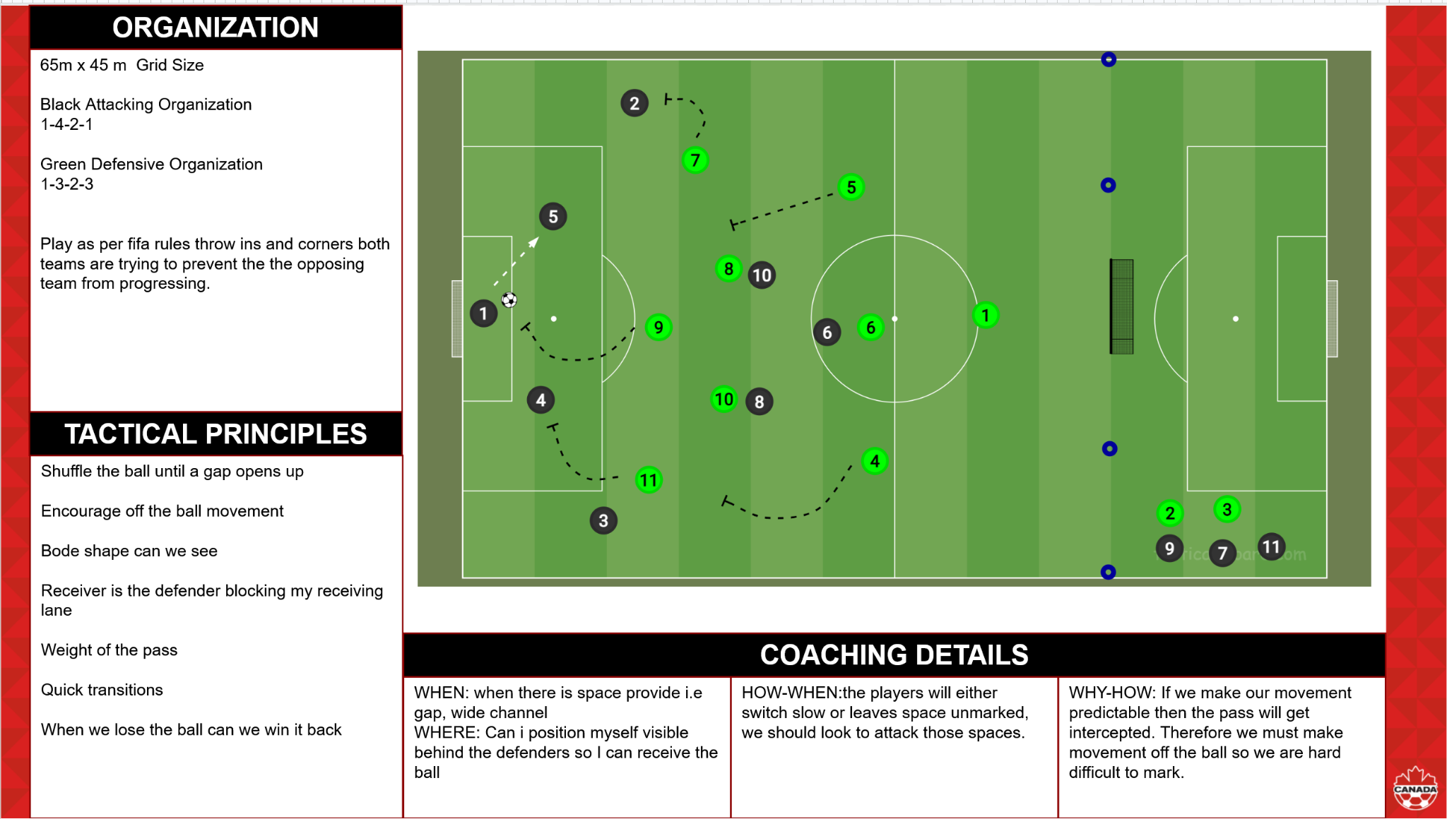

Practice Session 6
In the space below, insert your session plan details by selecting Insert > Image > Upload from Computer
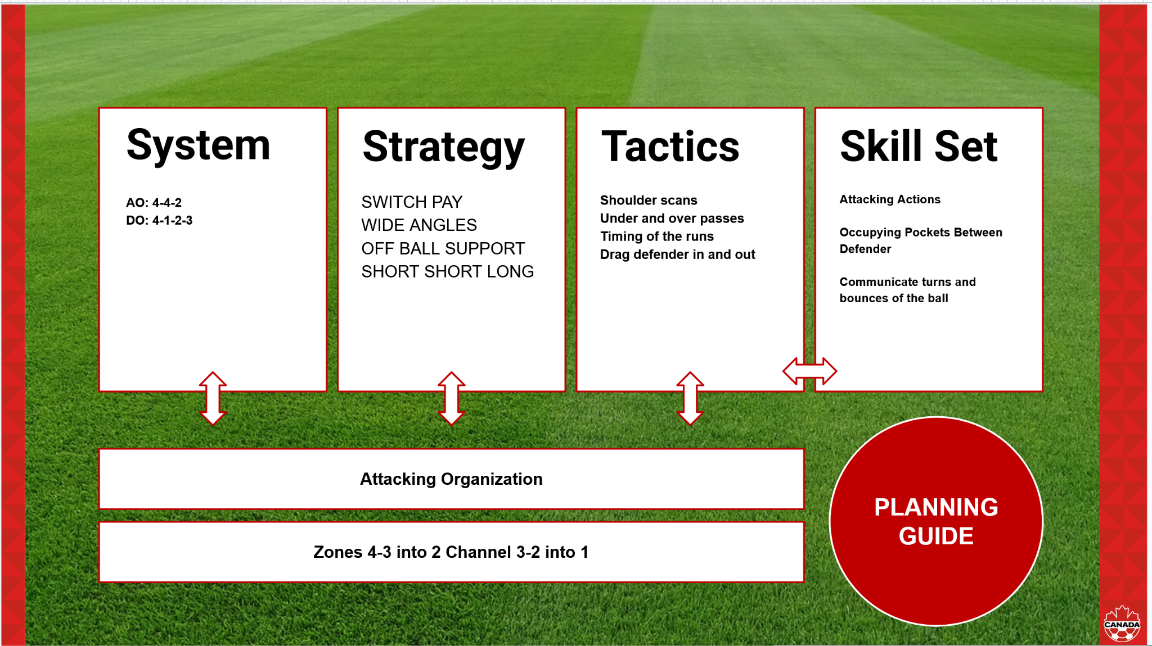

COACH DEVELOPER SUMMARY #3
Module 13 – Mental Health in Coaching

Love the idea of having them set developing (progress) goals and reflecting on these through journalling. Coaches and players often focus on wins and losses, which is not completely within their control. Process goals are within their control and can show them how they are going as a player regardless of results.

With this generation you can also ask them to find short clips of things they did well within game based on their goals they set. They are visual and technology-driven, so it supports their way of learning and connection to their reality.

How would you tie your ideas into supporting their mental health and recognizing when there is potentially a need to provide support to a player?
I would do constant checks on the players day to day and ask them
How they are doing and if all is wheel. And consistently encouraging them.

Module 14 – Coaching During Transitions of Adolescence

Good observation in recognizing the social comparison. This is not just something they do within sport but across all aspects of life within this age range. They view peer opinion as one of the most important and highly value the opinion of peers.

Your three strategies will create a very respectful supportive environment between coach and player but also player and player. Very important to create an environment where there is a standard of respect from everyone.

Love the modifications to the 4v4 SSG to foster the 4 C’s. Have you tried it within your environment? If yes, what did you observe from the players?
Yes I constantly try the 4 c’s I mentioned and they talk well to changes. Though sometimes they do complain because friends and packs in the team usually want to stay together but
Coach and Myself try our best to get them out of their comfort zone.

Module 15 – Men’s Excel Presentation

Appreciate you recognized the level of detail within the youth national team game model. I agree the game model should be tailored to the players and their current age/level. However, I would encourage you to consider how you would build out a full game model regardless of age/level and then how would you adapt it to the specific needs of your players or simplify the language. We can have each component but tailored to the current group we are coaching.

Module 16 – Women’s Excel Presentation

It is important to recognize the context of coach messaging. Her messaging after the Portland game is connected to performance and winning since they are competing in the Champions League. How we communicate in the context of development might be different.

Within your game model it is important to include your coaching methodology as this is how your players will learn it within the training environment.

Module 17 – Transformational Coaching During the Match

Within this reflection it seems you are scratching the surface. I would encourage you to dig deeper and reflect on how you would apply transformational coaching within a match.

How would you challenge the player? How would you support him if he wants able to keep his cool? What would be the strategies to help him maintain a level head?

Action Item by April 30, 2026: REFLECT ON HOW YOUR PRACTICAL EXPERIENCE WENT WITH EXECUTING YOUR OWN MATCH PLAY CONNECTED TO THE PLAYERS INDIVIDUAL DEVELOPMENT PLANS.

Module 18 – Coaching in a Match: Adjustments to Support Performance

What was the scenario and how did you address it? What did you learn from this process? Within a match how do you view the game through the tactical lens and adjust based on the opponent or your own teams performance? You mention addressing individual mistakes or subbing them but how does this support their development?

Action Item by April 30, 2026: add additional reflection as this does not meet the standard and does not connect to the module and presentation

Module 21 - PARENTAL INVOLVEMENT IN SPORT
Date: | Sunday May 10, 2026
Facilitator(s): | Dave, Miranda, Mike, Nino
Module Summary: | How can we positively get the parents involved in players development
TOPIC

ONE THING I FOUND VERY INTERESTING ABOUT THIS MODULE WAS...

A QUOTE FROM THE MODULE THAT STOOD OUT…
I was particularly interested in the diamond dynamic that exists between coaches and players' parents. This highlighted the critical nature of maintaining open lines of communication and explained why this relationship is so vital to the process.

Parents should be viewed as shareholders who offer essential player insights, helping us evolve into more effective coaches. We must operate in a partnership to successfully guide their children.

The "athletic triangle"—comprising the athlete, coach, and parent—requires constant, purposeful interaction throughout the season. This is especially true regarding the management of expectations and identifying further ways parents can support the athlete's journey.
MY OPINION

IN MY OPINION...

FROM MY OWN EXPERIENCE...

IN MY OWN LIFE...
In my opinion I found that it is a partnership where the player has better levels of development if the parent is involved in the development process and if the communication between myself and the parent is consistent and interactive.

From my experience not always are parents involved in the players development and dont want feedback but most times they do and when they do it really helps the players grow.

In my own life as a coach, I found it super helpful when coaches give me feedback. It's not very often that I've had a coach that gives me feedback but the ones that did I found it very helpful and tailored to my improvement as a player especially as a coach.
CONNECTION TO MY ENVIRONMENT

THIS CONNECTS TO MY ENVIRONMENT AND COACHING BECAUSE…
This connects to my coaching and environment because my life and football players play a major part in how I coach and how I play so I want it to rub off on my players. Working with

Module 22 - ATTACKING ORGANIZATION & ATTACKING TRANSITION IN ZONES 1-2 INTO 3
Date: | Monday May 11, 2026
Facilitator(s): | Dave, Miranda, Nino, Mike
Module Summary: | Attacking Strategy and Structure and Organization
TRANSFER THE ANALYSIS FROM YOUR ASSIGNED VIDEO

Analysis should include: 1) SYSTEM-STRATEGY of the opponents, 2) SYSTEM-STRATEGY of your team and any adjustments required aligned to your game model, 3) TACTICS that you can utilize for the assigned units & 4) Any required SKILL SETS for the positions of the assigned units.
- The strategy of the opponent is likely to press us and not let us build from the back by pressing our back 4 and having our midfielders fill in the gaps in between so that we are not able to break through their press.
- 2. My team is creating a W in the back line with a back 4 and then 3 in the middle but in the clip we can only see the defensive third of the pitch. The adjustments that we might make is to have our 8 and 10 drop a little more but based on the video there should not be any adjustments as what we are doing is working and we are breaking the press with the current strategy.
- 3. The Tactics we can utilize is that we want to move the ball side to side and progress in the wide channels and avoid central. Play we can do this by using the central midfielders as our options to support our wingers and when we find them in the wide channels they need to progress and attack the space.
- 4. The required skill set is the off ball movement and being able to drag defenders in and create space for other players to occupy. If there is no movement in the central units of 3 then there are not many options for us to progress and they have kept us in our half and not allowed us to progress.
ADDITIONAL REFLECTIONS & NOTES

Module 23 - ATTACKING ORGANIZATION & ATTACKING TRANSITION IN ZONES 2-3 INTO 4
Date: | Tuesday May 12, 2026
Facilitator(s): | Miranda, Dave, Nino, Mike
Module Summary: | Attacking organization and attacking transition
TRANSFER THE ANALYSIS FROM YOUR ASSIGNED VIDEO

Analysis should include: 1) SYSTEM-STRATEGY of the opponents, 2) SYSTEM-STRATEGY of your team and any adjustments required aligned to your game model, 3) TACTICS that you can utilize for the assigned units & 4) Any required SKILL SETS for the positions of the assigned units.
- The system strategy of the opponent was to force us wide and prevent us from penetrating through the wide channels. Their system was a mid block 4-4-2. They were pressing us and trying to force us to play wide areas.
- Our Strategy was to move the ball in between our back two and look to find one of our wingbacks wide so that they can look to attack or get a ball into the box. We were sitting in a 3-2-5 with or 8 sometimes dropping into the midfield to provide support.
- Our tactic could be interchanging in the midfield and playing the touch line on the wind channels to draw out the defenders and create more space in the middle. We can utilize this skill by using it to open up space in central areas so that we can find a penetrating space in the central channel and create gaps.
- Yes, we have to shift rotations, create gaps, transition between spaces. If we can drag our defender out.
ADDITIONAL REFLECTIONS & NOTES
Overall I think the strategy was good in Canada's favour but we struggled to find and complete the final pass in behind, usually playing the ball into the keeper.

Module 24 - DEFENDING ORGANIZATION & DEFENDING TRANSITION IN ZONES 4-3 INTO 2
Date: | Tuesday May 12, 2026
Facilitator(s): | Miranda, Dave, Nino, Mike
Module Summary: | Defending Organization & Defending Transition in zones 4-3 into 2
TRANSFER THE ANALYSIS FROM YOUR ASSIGNED VIDEO

Analysis should include: 1) SYSTEM-STRATEGY of the opponents, 2) SYSTEM-STRATEGY of your team and any adjustments required aligned to your game model, 3) TACTICS that you can utilize for the assigned units & 4) Any required SKILL SETS for the positions of the assigned units.
- The attacking organization of the opponents is that in a 4-3-3 they are trying to skip channel 3 from 2 and play directly into 4. They are trying to funnel between the back two and play balls into the box.
- We are defending in a 4-3-3 where we are compact in the middle which compliments my game model and we are looking to not allow them forward play. We want to play a high block and not let them progress forward.
- Some tactics that we can utilize is the depth and space in between. If we shift as a team and look to compact in the middle as a team they will struggle to penetrate in the middle and in turn we will force them to play lon but we must utilize our midfielder compactness.
- Yes, some of the skill sets are communication and balancing the field. So organization defensively and how we can do it as a team.
ADDITIONAL REFLECTIONS & NOTES

Module 25 - DEFENDING ORGANIZATION & DEFENDING TRANSITION IN ZONES 3-2 INTO 1
Date:
Facilitator(s):
Module Summary:
TRANSFER THE ANALYSIS FROM YOUR ASSIGNED VIDEO

Analysis should include: 1) SYSTEM-STRATEGY of the opponents, 2) SYSTEM-STRATEGY of your team and any adjustments required aligned to your game model, 3) TACTICS that you can utilize for the assigned units & 4) Any required SKILL SETS for the positions of the assigned units.
ADDITIONAL REFLECTIONS & NOTES

Module 26 - PERIODIZATION: DEVELOPING & MANAGING PHYSICAL OUTCOMES
Date:
Facilitator(s):
Module Summary:
TRANSFER THE UPDATED SESSION PLAN WITH DETAILS ON HOW TO MANAGE PHYSICAL OUTCOMES

Google Slides: Copy your Slides from the Session Plan Template > Click in the box > Paste > Link to Presentation
Microsoft Powerpoint: Take a screenshot of the Slide > Click in the space below > Insert > Image > Upload from Computer
TOPIC

ONE THING I FOUND VERY INTERESTING ABOUT THIS MODULE WAS...

A QUOTE FROM THE MODULE THAT STOOD OUT…
MY OPINION

WHAT ARE MY STRENGTHS AND WEAKNESSES AS A COACH IN RELATION TO PERIODIZATION AND LOAD MANAGEMENT?
CONNECTION TO MY ENVIRONMENT

WHAT STEPS CAN I TAKE TO IMPROVE MY KNOWLEDGE AND SKILLS IN THESE AREAS?

Module 27 - ANALYZING INDIVIDUAL PERFORMANCE
Date:
Facilitator(s):
Module Summary:
TOPIC

ONE THING I FOUND VERY INTERESTING ABOUT THIS MODULE WAS...

A QUOTE FROM THE MODULE THAT STOOD OUT…
MY OPINION

IN MY OPINION...

FROM MY OWN EXPERIENCE...

IN MY OWN LIFE...
CONNECTION TO MY ENVIRONMENT

THIS CONNECTS TO MY ENVIRONMENT AND COACHING BECAUSE…

Module 28 - EFFECTIVE FEEDBACK TO PLAYERS: DEVELOPMENT PLANS
Date:
Facilitator(s):
Module Summary:
TOPIC

ONE THING I FOUND VERY INTERESTING ABOUT THIS MODULE WAS...

A QUOTE FROM THE MODULE THAT STOOD OUT…
MY OPINION

IN MY OPINION...

FROM MY OWN EXPERIENCE...

IN MY OWN LIFE...
CONNECTION TO MY ENVIRONMENT

THIS CONNECTS TO MY ENVIRONMENT AND COACHING BECAUSE…

Practice Sessions

Please upload four (4) full practice sessions that compliment your functional or phase of play from modules 22-25. Ensure that the following details are included:

- Session Objective & Learning Intentions
- Age and level of the players
- Moment of the Game
- System-Strategy identified for both teams
- Tactics-Skill Sets for the team you are coaching
- Resources
- Overview of each activity inc. time
- Progressions / Regressions
- Role of the assistant coach
- Coaching details (WHAT-WHO-WHERE-WHEN-WHY-HOW)
- Diagram that presents a specific moment and aligns to the coaching points

Practice Session Example
In the space below, insert your session plan details by:
Google Slides: Copy your Slides from the Session Plan Template > Click in the box > Paste > Link to Presentation
Microsoft Powerpoint: Take a screenshot of the Slide > Click in the space below > Insert > Image > Upload from Computer


Practice Session 7
In the space below, insert your session plan details by selecting Insert > Image > Upload from Computer

Practice Session 8
In the space below, insert your session plan details by selecting Insert > Image > Upload from Computer

Practice Session 9
In the space below, insert your session plan details by selecting Insert > Image > Upload from Computer

Practice Session 10
In the space below, insert your session plan details by selecting Insert > Image > Upload from Computer

Final Practical Coaching Video Reflection

Once you have filmed your practical video, complete the following self-reflections under each competency consideration by providing evidence according to the criteria. Please use timestamps where appropriate.
Competencies: Clarity, Adaptability and Problem-Solving (See the handbook for a more detailed examples)
- The coach clearly communicates objectives, utilizes tools effectively, and uses language consistent with their established game model.
- The coach manages the environment effectively, modifies sessions based on player needs, adjusts difficulty to match objectives, and utilizes varied restarts to challenge players.
- The coach communicates solutions effectively, understands the impact of decisions on outcomes, and recreates game moments to enhance player problem-solving.

In the space below, insert your self-reflections for these competencies

Competencies: Organization, Time Management and Self-Regulation (See the handbook for a more detailed examples)
- The coach understands session methodologies, designs cohesive sessions, and meticulously plans all essential components, including identifying key players for unit cohesion.
- The coach communicates expectations clearly, encourages independent exploration before intervention, and provides appropriate playing time considering player needs and session objectives.
- The coach remains composed under pressure, exemplifies their values, and aligns with the club's philosophy.

In the space below, insert your self-reflections for these competencies

Competencies: Empathy, Compassion and Critical Reflection (See the handbook for a more detailed examples)
- The coach creates a safe learning environment, actively seeks feedback, and allows players opportunities for practice after interventions.
- The coach values player input, fosters an inclusive environment, and uses a feedforward approach in feedback.
- The coach understands strategic positioning for effective coaching, observes key moments during sessions, and facilitates debriefing sessions for player reflection and self-evaluation.

In the space below, insert your self-reflections for these competencies

Competencies: Authenticity, Engagement and Risk Management (See the handbook for a more detailed examples)
- The coach displays confidence in their vision, prioritizes personal connections with players, and shares personal anecdotes to build rapport.
- The coach engages players in understanding objectives, employs diverse coaching approaches, and creates a fun, game-like environment.
- The coach prioritizes safety by assessing requirements before the session, monitoring the environment throughout, and regularly checking on players' well-being.

In the space below, insert your self-reflections for these competencies

Competencies: Communication, Relationship Building and Conflict Resolution (See the handbook for a more detailed examples)
- The coach adapts communication style to suit players, motivates effectively through words and tone, and speaks confidently using clear language.
- The coach fosters a collaborative environment for exploring solutions and encourages active sharing and integration of knowledge during briefings.
- The coach addresses player disagreements and reinforces team objectives, while also demonstrating a thorough understanding of game rules.

In the space below, insert your self-reflections for these competencies

GAME MODEL PLANNING (SCRATCH PAD)
As you continue to complete your portfolio add the key details of your Game Model in preparation for creating a final document for submission.

WHO WE ARE?
CLUB PHILOSOPHY
My coaching philosophy is calm in possession and look to build and combine passes before we go forward. Attack from wide channels and find our striker in central position for one or two touch finishes on goal.
CLUB GUIDING PRINCIPLES
The club's guiding principle is a positive club culture, keeping the team structured and organized during and throughout the season. The importance of or phases of the game and how they should be developed and trained during the season. Players continually assess their ability and see if they have made improvements. And the coaches' ideas and tactics should be taught to the players through training sessions and in class sessions so that the players can learn new tactics and football ideas to increase their own.
COACHING PHILOSOPHY
The club's guiding principles align with my coaching philosophy because it is all about the players and ways that we can help them improve. We want this to be a way that we can have the players grow and make them the best player possible with the resources that we have.

HOW DO WE COACH?
TRAINING DESIGN PRINCIPLES
In training can we recreate an instance in the game that we are struggling with or that we need to learn to prepare us for the match. Always looking to tailor or session to the match and problem that we might have to solve.
PREFERRED PRACTICE METHODOLOGIES
My preferred practice methodologies are can we create smart players that have a great understanding of the game.
My coaching values are demonstrated both on and off the field. On the field, I prioritize clear communication, encourage players to take ownership of their actions and responsibilities, and foster a culture where mistakes are viewed as vital steps in the learning process. Off the field, these values guide my interactions by ensuring I actively listen to player concerns, treat every individual with respect, and uphold a commitment to consistency and transparency in all decision-making.
PREFERRED COACHING APPROACHES
When to play the long ball and the organization when we have decided to go long. Key triggers and our attacking organization when we have decided to play long.

HOW WE WANT TO PLAY?
STYLE OF PLAY
Our style of play would look to attack in a 1-4-4-2 and defend in a 1-4-2-3-1. We want to build from the back and progress through wide channels with over loads and overlapping runs.

Defensively we want to stay compact and not allow them to attack centrally. We want to have a counter attacking option up the field who can provide us depth should we want to create a quick counter attack.
MOMENTS OF THE GAME

Recommendation: Use graphics and diagrams




PITCH GEOGRAPHY

Recommendation: Use graphics and diagrams

SYSTEMS

Recommendation: Use graphics and diagrams
We want to play attacking football where we look to move the ball up the field from the wide channels, and have players attacking channels 3 and 4 in zone 4. This is why we want to attack with a 1-4-4-2 with only two attacking players. We can have our wingbacks get into central positions when we are looking to get crosses into the box. When we are looking to attack we want movement off the ball and our 7, 9 and 11 look to make runs into the box when then 3 or 2 is making overlapping runs to support the wingers in front central positions or in zone 4. We like to build from left to right in terms of the pitch meaning we might start the ball from our left back and we want to be trying to feed balls into our right winger and vice versa. We are looking to make our 6 8 and 10 rotate positions in the mid field when we are looking to build especially when we are looking to build out from the back using our goalkeeper.They need to be going into or zone 1 and help our 3 or 2 our full backs get out from the back and supporting them we also want our wingers supporting our 3 and 2 depending on the side help the full back get out of zone 1 when we are trying to build with the keeper. We look to attack from playing balls into the box and having our front 3 7,9,11 make runs into the box and likely our 8 and 10 attacking the available space in front of the 18 or behind our striker so that they can attack any balls that may be parried away by the goalkeeper. The 8 and 10 and 6 must be confident shooting from outside of the 18 yard box and applying pressure when we need to press. We also have attacking mode where we like to play long and try to push our back line defensive line up the field into zone 2 and have our keeper trying to find our front 3 and have them try to extend the ball and have our wingers or midfield run onto the ball and see if they can get in on goal or contest the second ball. And encourage forward play in behind the opposing teams back line.

When we defend we want to be in more of a 1-4-2-3-1 so that we can be more defensive and be compact and force the opponent to the wide channels. We want to enforce a low block where we only look to defend zones 1-2 into 3 but avoid a high press/ This would provide us the legs to counter quickly and disperse back into our attacking formation. When we defend we want to do it in groups and force them to play long, not allowing them to play in the middle. We can do this by not pressing their wing backs and allowing them time on the ball and pressing either there 4 or 5 which would be pressed by our 9 who is preventing the 4 playing back across to the 5 if we are in a high press the 9 would stay in between the two and deny play between the two. The wing backs would prevent the full back from finding his winger and the midfielders would prevent the full back from playing the ball through the middle by man marking their midfielders and not allowing them to receive the ball. They need to really man mark in the middle and transition from side to side as that happens. When we are in our defending half i.e our zone 1 our midfielder needs to drop and help support the defending. Our 4 and 5 are looking to win the ball and clear the ball from our zone 1 and until then we are in a danger zone. We can combine with our keeper if we are not under immense pressure when we have first won back the ball. Defensively. When we are defending long balls likely plated from the opposing team keeper we want our back line holding a strong line and if one steps to header the ball we want one challenging the aerial ball and our 5 and 3 and 2 providing cover. Same thing if our 5 attacks the aerial ball our 4 3 and2 should be providing cover and support.
STRATEGIES

Recommendation: Use graphics and diagrams
Our strategy would be to stay compact when defending and pick our moments to step out wide and defend wide areas. I would like our defenders, especially my CDM to stay central and go out to help the 2 or 3 defending in 1v1 situations. This would provide the defending depth we need to be successful. Also as one CDM shifts to defend the wide channel the other being the 6 or the 8 should also step into the central zone 3 and help defend the gap that has been left open.
TACTICS

Recommendation: Use graphics and diagrams
Always looking to play forward but when we cannot play forward look to reset the ball and maintain possession. We should not be looking to constantly play long. We should be using the wide channel to bring the ball forward and using our central players to help us transition the ball wide when need be. We can also keep working on distribution of the ball to wide areas helping us get forward.

THE FUTURE CANADIAN PLAYER
SKILL SETS / PLAYER BEHAVIOURS

Positional Profile Example
In the space below, insert your session plan details by:
Google Slides: Copy your Slides from the Session Plan Template > Click in the box > Paste > Link to Presentation
Microsoft Powerpoint: Take a screenshot of the Slide > Click in the space below > Insert > Image > Upload from Computer
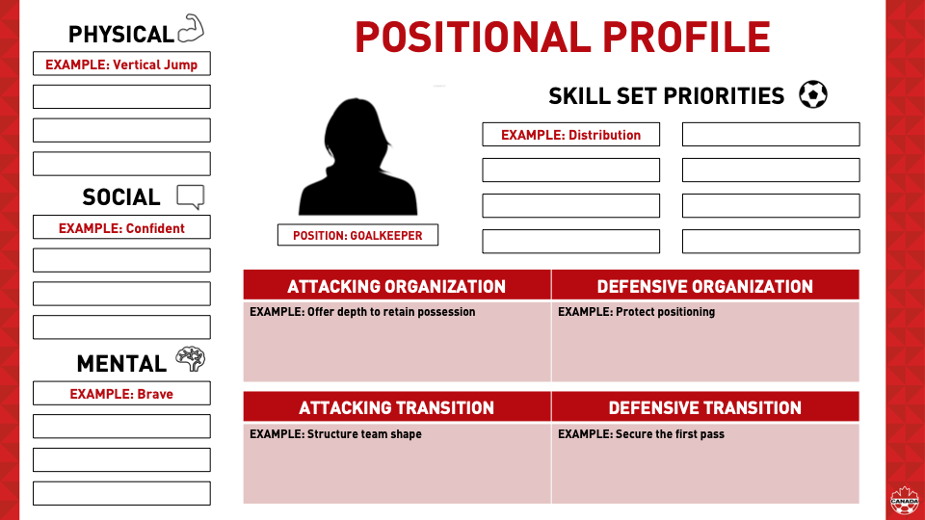

GOALKEEPER
I prefer my goalkeeper to maintain a high line, actively organizing and communicating with the back four to push the defensive unit forward. They should be a versatile distributor, comfortable playing direct or building short depending on match requirements, and act as a switch for the point of attack. As the last line of defense and the first to spot breakdowns in play, the goalkeeper must be a vocal leader who commands the area. I expect them to be an aggressive ×sweeper-keeper× who is willing to come out of the box to win early balls when appropriate, demonstrating the bravery and composure necessary to handle pressure outside the penalty area.
CENTER BACK
I want a center back who is vocal and very brave. He controls the back line and communicates with his defender partner. They work hand in hand in making sure that things stay organised and keeping his wingback discipline on their positions and parts and moments of play. He should be a great communicator and great at heading the ball and clearing the ball to clear any aerial threat he should be calm on the ball and be able to gradually move the ball up the pitch combining with our other center backs, our full back and even our midfielders when we need to be. This is important because we want our center back to be our starting point for our build up and a solid back line for our defence.
FULL BACK
A full back should go forward and come back to the defender making overlapping runs and taking on players down the side line when need be. He should always be able to combine with our striker and midfield to help switch the position of play, he should be able to play a long ball when we need to get out from the back and the press is too heavy. He should decide his moments when he wants to play forward or when we need to use our goal keeper and move back . He is quick and a defender and specializes in one v one defending on the wing. Especially with speedy wingers who use pace to beat defenders. You need to be able to clear aerial balls as a defender and be able to be physical with strikers who may want to use physicality not eyeball. We need to stay organised with you center back and communicate at al time when we want o move the line and drop the line also communicate with our goalkeeper when we are looking to build out from the back
DEFENSIVE MIDFIELDER
A defensive midfielder is a defender's best friend, constantly getting stuck in and winning aerial battles. This player makes big tackles so the center-back doesn't have to and works to stop shots from outside the 18-yard box. They help the #8 and #10 transition the ball from one side of the field to the other and communicate with defenders to help the team escape danger when building out from the back. Aggressive by nature, the defensive midfielder helps the team move up the field and plays deep balls behind the opposition's back line for the #7 and #11 to run onto. He needs to be strong, highly disciplined, and technically proficient, capable of receiving the ball with a defender on his back and playing out under pressure, even when double-teamed. During play, he must identify markers and, when out of possession, always know who he and his midfield partners are marking. He follows his marker into open spaces if the center-back is occupied or out of position. While he can rotate with the #8 and #10 To support an attack, he must return to his defensive position once play resumes its structure.
ATTACKING MIDFIELDER
The attacking midfielder is the primary link for our striker and wide forwards, providing the service they need to generate goal-scoring opportunities and advance play into the final third. This player is responsible for dictating our possession and switching the point of attack if one side of the pitch becomes overloaded. We aim to receive the ball from the defensive right and attack the offensive right, or vice versa, utilizing diagonal attacks to play deep balls behind the defensive line into wide channels 1 and 2. By creating overloads with our #6 and fullbacks, the attacking midfielder helps us combine to penetrate the box with crosses. When play reaches the edge of the 18-yard box, the attacking midfielder must be comfortable shooting from distance or recycling possession wide to find a striker. While they can take players on 1v1 to create space, their main focus in the final third should be attacking the top of the box as the striker and wide forwards move inside to challenge for the ball.
WIDE FORWARD
Our wide forwards are elite speed threats capable of beating defenders with pure pace. They are tactically intelligent, utilizing their speed when it best serves the team's objectives. Thriving in 1v1 situations and isolated scenarios, they consistently best their markers through quick dribbling, sharp turns, and decisive cuts. Their primary aim is to either drive hard, low balls into the box or combine with the full-back and midfielders to overload channels 1 and 2. By penetrating the side channels of the final third, they create crossing opportunities for the 7, 9, or 11, while the 8 and 10 look to attack the ball for one-time finishes.Defensively, they must adapt to the game state. In 2v1 situations against dangerous opposing wingers, they are required to drop back, track runs, and prioritize defensive duties over offensive positioning. During build-up play, they serve as a wide outlet for diagonal passes, looking to receive the ball in behind or down the wide channels. When the goalkeeper plays aerially, they are instructed to anticipate long balls headed on by the striker, using their speed to transition into 2v1 or 2v2 scoring opportunities alongside the opposite attacking winger.
CENTER FORWARD
Our center forward is physically strong and excels at holding up play to involve the wingers and the number 8 and 10 in the attack. Acting as a hold-up striker, he is also dangerous shooting from within the box and proficient at distributing the ball wide, enabling our wingers to make penetrating runs and deliver crosses. Defensively, he is responsible for pressing the opposing center-backs and the goalkeeper during poor back-passes. While his defensive load is generally lighter, he must remain disciplined to stay in the box during final-third attacks to prevent opponents from easily transitioning when we aren't pressing or are sitting in a low block. It is vital that our forward understands our pressing triggers based on the game state. He must be an intelligent finisher, capable of scoring in tight spaces within the penalty area through technical skill and precision. A great forward is selfless, acting as a marksman who balances scoring with creating goals through the final pass to ensure team success. These characteristics define his role: a technical threat in the box who is also willing to track back and assist the defense when the moment requires it.

